## **FYIs**

* **Tech count:** We have another 20 starts slared for this week, from the reporting below you can see we are steadily climbing back in the right direction (1629 active techs, number of techs on LOA also slowly decreasing down to 112), but we need to move faster. This is where 1099 comes in (more on that below)

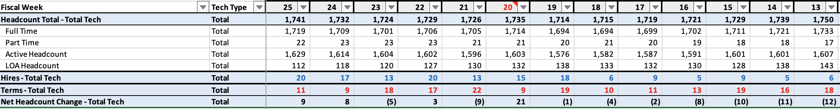

* + **1099:** We dispatched a total of 21 Sears Protect Home Warranty jobs this week to 2 1099 firms, not quite hitting the 30 target. Nonetheless, we have started to deploy and are iterating quickly as we go. **So far:** 
    - 13 jobs assigned in future date
    - 4 in progress (we will break down into waiting parts, waiting service on this dashboard next)
    - 3 jobs completed with no parts needed (12522915, 12594743, 12590550)
    - 1 job cancelled by customer (customer no longer needed service)
  + **Goal for next week:** sign up additional vendors, dispatch an additional 20 jobs, ensure 100% of jobs taken get timely updates and that we capture all necessary data from 1099s (creating a product where non compliance is not possible).
  + **Quick learnings from this week:**
    - The way we collected certificates of insurance previously was not sufficient and didn’t protect us per Lori. It’s great that we’ve caught it but now the bad news is that we need to go get new insurance certificates filled for each vendor. We’ve created a very simple template to show them what we need from each vendor prior to being able to dispatch jobs. We are automating this to move significantly faster
  + **WIP/MVP/V1 Dashboard:** We are tracking at the service order level and are sprinting to iterate on this dashboard (**MVP** please bear with us as we built this in the last couple of days) and to ensure the providers are using it the way we need them to. We are aware that we need to build out significantly more detail - we’re building the plane as we fly it and will continue iterating on this quickly.
    - <https://shs-1099-job-board.replit.app/>
    - user name – admin
    - password - VRS_1099@#_PILOT
* **Talent:**
  + **Melissa Auth:** Spoke to Melissa, she’s thrilled and very excited to join us for a trial period. She got out of her lease and was travelling – she's now figuring out how to get back to Miami to get started. She’s anxious to get going and said she’d come back to me early this week with a good start date – she said she’s going to find an apartment, move back and dive in.
  + **Patrick:** Please let me know if I could be helpful in speaking to him. I have a very good relationship with him and spoke to him last week about how things are going. I think he understands this is not working out from an SHS perspective. He told me that he’s lined up marketing leaders in each of the sub business units, Jesse is taking point for in home repair and Justin and Josh are leading marketing on the service contracts side. I don’t want to overstep here. I also don’t think he will be surprised.
  + **Paul** (Toptal finance automation with Shane) starts Monday, I spoke to Shane and he said that he would send the work plan over and ensure you got time with him to engage on his work
  + **Dannielle:** Final round of sell conversations, she will speak to Andrei one last time and then we will make the offer
  + **Shwetabh:** I have time with him this week
  + **Charles Englander:** Anand’s new interesting find. Will speak to him this week
  + **HR, Legal + Finance Reductions:** I have removed an incremental 5 roles out of the centralized HR function and have pushed 8 roles into the respective BUs that they support. I continue to work with BJ on the proposals for the other shared services.

## **Financials**

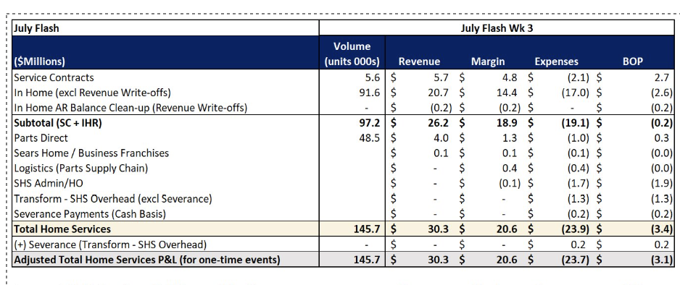

**In Home Repair:**

* 91.6k Completed Calls, down (5.4)K vs Forecast or (5.6%) driven by (2.4)K D2C and (3.6)K Cinch HW completes, Completes down (2.6)K vs Prior Week

**Vs Prior Week**

* IHR July BOP excluding write-offs $(2.6)M, $(0.5)M to Prior Week; Lower Advertising Expense +$0.1M partially offsetting (2.6)K shortfall in completions, increased Truck expense $(0.1)M, and Tools expense $(0.1)M

**Vs Forecast**

* IHR July BOP excluding write-offs $(2.6)M, $(0.6)M to Forecast; Lower COGS rates and Lower Advertising Expense partially offsetting (5.4)K shortfall in completions
* Gross Revenue net Cost of Parts $(0.9)M vs Forecast
  + Gross Revenue worse to Forecast driven by $(1.3)M on lower volume
  + Cost of Parts (excluding parts unaccounted for) +$0.3M to forecast driven by lower volume
  + Parts Unaccounted For +$0.2M driven by circuit board returns credits
* Service Payroll and Benefits favorable +$0.2M
* Truck Expense $(0.2)M unfavorable driven by increased repairs expenses and truck insurance claims
* Non-Cap tools and Equipment expense unfavorable $(0.1)M driven by tools orders for 120 additional techs
* Advertising Expense +$0.5M driven by Marketing spend optimization

## **B2B (Joe)**

Key Metrics

*(Sun–Fri Creates, Sun–Thurs Completes)*

* **Metric 1: Avg. Profit per B2B Job:** **$64** | Up from $59 last week
* **Metric 2: Job Volume (B2B Partners):** **8,421 creates** | ▼ Down from 9,062 — modest decline
* **Metric 3: Job Completes:** **5,725** | ▼ Down from 6,114 — aligns with softer creates from prior week
* **Metric 4: Cancel Rate:** **9%** | WTD for Jobs created this week
* **Metric 7: AHS Replacement Rate (W18–W24):** **~10% avg** | ▶ Holding stable — optimized triage sustaining positive trend

What Got Done This Week

**Samsung**

* Samsung rates officially effective **7/25**

**LG**

* **Offset rights successfully removed** from contract
* Ekta provided redlines to LG legal team; pending formal response

**American Home Shield**

* Met with field managers for **Kansas City (Melanie Denny)** and **Beaumont (Todd Springer)**
  + Key concern: **Survey scores** are the main barrier to growth
* AHS Survey FTP file issue **resolved 7/25**
* Brent (AHS Director) aligned on field manager rotation — SHS to meet with all monthly

**Choice**

* First **test appliance order received** ✅
* Full activation pending — Joe Telesca follow-up daily
* Positive partnership meeting **7/24** introducing our new Head of HVAC, Alex

**GE**

* Productive meeting with **Tracey Janey (7/25)**
  + GE committed to **increased Tier 1 & 2 volume**
  + Provided process for SHS to **self-entitle RAC-assigned IW calls**
  + GE proposed **rate reduction in Tier 3** for RAC calls — SHS reviewing

**Rent-A-Center**

* Feedback shared with RAC on Whirlpool delay
* Whirlpool meeting **7/23**: RAC applied pressure to accelerate
* RAC may approve **pilot launch without Whirlpool** — under review

**Whirlpool**

* Continued escalation with **John O’Donnell**
* SOG (“Service Order Guidelines”) still **not delivered** — critical blocker to agreement redline

**First American**

* Strong partner meeting with **Tony Davidson**
  + Reviewed scorecard and improved **recall rate**
  + Additional **California and Southern markets reactivated**
  + **Insurance policy Contact provided** for renewal

**Assurant**

* Reaffirmed SHS position on **parts short-pays** with Stewart Clark— must be disputed and resolved collaboratively

### Next Week’s Targets

* **EMA**: Final prep for **7/29 onsite meeting**
* **GE**: Respond to **RAC rate counter proposal**
* **Assurant**: Host **pricing review with Satish and Andrei**
* **Whirlpool**: Obtain **SOG document** and deliver blended rate model (Tiers 1–3)
* **AHS**: Follow-up on **monthly field manager meeting rollout** — next up: Bradley Christie (NorCal)
* **First American**: Finalize **COI for 8/1 renewal** — prevent account hold
* **RAC**: Determine viability of **pilot go-live without Whirlpool**

Technician Profitability & Success (Rob)  
  
**Key Metrics**

* Pay/Rev: 29.9% (Target: 23.5%) | Improved 0.1% from last week & up 0.4% from Baseline (29.5%)
* PPT Profit/Call: $67.80 (Target: $70) | Improved $2.15 from last week & up $7.80 from baseline ($60)
* Recall %: 8.29% (Target: 8%) | Increased 0.19% from last week & down 2.21% from Baseline (10.5%)
* Tech On The Way Usage%: 84.07% (Target: 90%) | Improved 1.93% from last week & up 15.07% from Baseline (69%)
* Unclocked Time%: 17.52% (Target: 15%) | Improved 0.18% last week & down 4.48% from Baseline (22%)
* Sears Protect Conversion%: 4.53% (Target: 7.5%) | Decreased 0.74% from last week & down 1.47% from Baseline (6%)
* Cancels >10 mins: 340 (Target: 200) | Improved 5% from last week & up 5% from baseline (323)

**What Got Done This Week**

**Expanding Available Capacity**

Will Watkins continues to expand technician capacity through targeted enhancements to the Extra Hours tool. This week, a **major upgrade** was launched: technicians now receive **SMS notifications** when their requests for extra hours are **approved or denied**, eliminating the need to log back in to check their status. For approved requests, the tool also sends a **day-before reminder**—aimed at reducing **no call/no shows** through proactive communication.

The **SMS campaign** targeting techs whose skill set and planning area match a high number of unresourced jobs also remains active. **571 technicians** received outreach this week encouraging them to submit availability.

Since launch:

* **8%** of the technician population has participated
* **2,640 total hours** added to the schedule
* Top contributing districts:
  + **8035 (Atlanta)** – 399 hours
  + **8169 (Denver)** – 293 hours
  + **8147 (San Antonio)** – 215 hours
  + **8175 (Virginia)** – 155 hours
  + **4766 (Ohio Valley)** – 155 hours

**Technician Productivity Initiative**

This week, the cross-functional team led by **Rob Gerlach**, **Carl O’Neill**, and **Will Watkins** formally launched the Technician Productivity Initiative, focused on reducing the number of technicians attempting only three or fewer service calls in an eight-hour shift. Will provided route-level and time tracking data to help pinpoint the core drivers of low daily productivity, and the group aligned quickly on immediate priorities.

Key contributing factors included pacing and job duration, call avoidance, time tracking behavior, tech supervisor expectations, late starts and early punches, and union-related constraints. **Repeat offenders** will also be prioritized for targeted follow-up as part of the **accountability track**. The team is beginning with low-effort, high-impact solutions and will launch a **daily stand-up next week** to accelerate resolution and drive measurable progress.

**Solving Incorrectly Created Orders**

The automated process of identifying and routing incorrectly created D2C service orders to Felicia Filyaw’s offshore team remains highly effective. This week, 131 orders were flagged and submitted for cancellation, with only 3 still open. This continues to prevent downstream issues for technicians by removing problematic jobs before they reach the schedule.

A breakdown of the incorrectly created service orders shows that **52% originated from SHS.com**, **33% from Kairos**, and the remainder from MSO. In response, MSO managers were added to the notification emails to support coaching and correction at the source.

To further strengthen detection, **Will Watkins has gained access to the Snowflake table containing active Protection Agreement (PA) data**. This enhancement will allow the tool to **flag D2C service orders where the merchandise is already covered by a PA** and route them through the existing cancellation process—**broadening the range of incorrectly created orders that can be caught and addressed**. This logic will be added to the tool next week.

**Tech Supervisor Assignments**

Carlos Leon continued advancing efforts this week to strengthen field leadership by resolving open reporting gaps and accelerating hiring across multiple districts. These actions reduce elevated supervisor-to-tech ratios in areas above target thresholds, improving support quality and frontline alignment.

Following the recent retirement of **Walter Rozenbeck Jr.**, fourteen technicians who were previously unassigned have now been realigned under active Tech Supervisors:

* **District 8096**: 4 techs reassigned
* **District 8162**: 8 techs reassigned
* **District 8555**: 2 techs reassigned

Progress also continued on Tech Supervisor staffing. Two internal candidates were officially promoted this week, and offers are in motion for additional districts:

* **Brandon Brownlee** was promoted in **District 8206** (Mississippi) and now supports 6 technicians.
* **Ismer Herazo** was promoted in **District 8380** (Newark) and now supports 9 technicians.
* **Eduardo Nicasio** was interviewed in **District 8147**; an offer will be presented Monday, **July 28**.
* **Paul Flak** has verbally accepted the position in **District 7670**; promotion is currently being finalized.

**Automated Coaching Bots**

Nicole Martin’s team successfully launched the **Parts Returns Bot** to the full technician population this week, marking the first bot to scale beyond the supervisor testing group. This automation identifies when not-needed parts or deleted parts are not returned within a reasonable timeframe, reinforcing compliance with return policies and helping prevent unnecessary inventory loss.

The launch follows a targeted pilot with tech supervisors, during which exclusion logic and technician-facing language were refined to ensure clarity and drive adoption.

A total of **171 SMS notifications** were sent to technicians this week, covering two types of violation: **71 for overdue parts** and **100 for unprocessed deletes**. Because some technicians were in violation of both categories, the total reflects **159 unique technicians** who received a notification.

This dual-notification approach ensures full visibility into parts issues across multiple behaviors and is functioning as intended to surface technicians who require follow-up on more than one front.

As of July 25, the bot remains in full production and will continue running daily as part of the broader coaching automation rollout.

**SOP & Policy Change Request Enhancements**

To strengthen governance and transparency around material changes, Nicole Martin’s team implemented enhancements to the IHR SOP & Policy Change Request Board this week. Two new categories—**“Requests to Add Material”** and **“Requests to Remove Material”**—were launched to support SHSAI-related updates.

These additions create a **centralized, trackable workflow** for managing material revision requests, allowing stakeholders to submit, monitor, and follow through on changes more efficiently. The update ensures better coordination across teams and helps prevent gaps or delays in implementing approved changes.

**Serviceable Brands Expansion**

Carlos Leon led critical progress this week in expanding the list of serviceable appliance brands available through SHS. Two new brands—**Beko** and **Thor**—have officially launched, enabling customers to schedule service for a broader range of products via MSO and SHS.com.

* **Beko**: Now serviceable for refrigerators, ovens, cooktops, dishwashers, and laundry products
* **Thor**: Now serviceable for refrigerators, ovens, cooktops, microwaves, dishwashers, and laundry products

Additionally, Carlos submitted request **STSD-1422** to onboard **Briggs & Stratton** as a serviceable brand. Full integration is expected by **July 29, 2025**.

**BYOV Program Updates**

Carl O’Neill continued progress on restarting the **Bring Your Own Vehicle (BYOV)** program. **Enrollment documentation** is being updated by **Malory**, **Crystal**, and **Rocco**. Although no new enrollments occurred this week, two additional technicians — **Zak McMillan** and **Paul Dowdy** — expressed interest in joining once the new process is finalized. Meanwhile, two other technicians, **Sean Bishop** and **Brian Mills**, initially planned to enroll under the previous **$0.67/mile** reimbursement rate but have since opted out following the revised **$0.57/mile** rate.

**Technician Accountability and Compliance**

Carl O’Neill led several key interventions this week to uphold technician accountability, ensure policy compliance, and maintain safety expectations in the field:

* Terminated technician **Justin Nguyen (8366)** during the probationary period. All separation documentation and asset recovery protocols were completed.
* Issued **final warning to Zak McMillan** for multiple safety violations, including a second accident within 18 months, covering the dash camera, and disregarding management directives to stop driving post-incident.
* Conducted EPV coaching with the following technicians:
  + **JC Rodriguez** – Seatbelt violation. Technician acknowledged the policy and committed to compliance moving forward.
  + **Keith Griffin** – Cell phone usage while driving. Technician acknowledged the policy and agreed to refrain from phone use while operating the vehicle.
* Confirmed **termination of Travis Rivers**, effective 7/23, following the conclusion of an LP investigation. Coordination for asset retrieval was arranged with his Tech Supervisor.

**Technician Retention**

**Ricardo Espain’s retention efforts** this week led to the successful **saving of two technicians**, with continued progress across a critical pipeline of **at-risk team members**. While several long-tenured employees announced their **retirement**, work remains active to retain high-performing technicians expressing concerns around **pay equity**, **workload**, and **growth opportunities**.

***Saved Techs***  
• 8366 – *Isaac Zermeno*: Retained with a schedule adjustment.  
 • 4766 – *David Kaczmarek*: Retained after route modifications based on technician feedback.

***Retirements***  
 • 8162 – *Walter Rozenbeck Jr*: 36 years  
 • 8175 – *Bryan Cannon*: 40 years  
 • 7323 – *Daniel Gomez*: 39 years

***Working to Retain***  
 • 8158 – *Travis Texeira*: Cross-training request; under review.  
 • 7995 – *Marcus Burkham*: 29 years; seeking compensation for added responsibilities.  
 • 7084 – *Madjid Fetmouche*: Long-tenured generalist; pay request under review.  
 • 8420 – *Eric Kelly*: High SPHW rate, high recalls; request on hold pending LP review.  
 • 8555 – *AJ Ashfaq*: Top HVAC performer; competing offers at $38/hr.  
 • 7084 – *Richard Mohr*: Evaluating resignation due to pay equity concerns.  
 • 7670 – *Glenn Matson*: Pay request under review.  
 • 7670 – *Shane Williams*: Pay request under review.  
 • 7670 – *Scott Dobrowolski*: Pay request under review.

***Resignations***  
 • 7088_M – *Bernard Stewart*: Left for better pay and benefits; declined counteroffer  
 • 4766 – *Dwight Perry*: Quit without notice; cited flexing and income loss.  
 • 7435_S – *Gavin Sanderlin*: Cited lack of support and FSSL parts issues.  
 • 8420_A1 – *Troy Rich*: Departing after 42 years   
 • 8175_F – *Tyrese Hardy*: Accepted a federal HVAC position with compensation at $45 per hour

**Leave of Absence Engagement**

**Ricardo Espain** continues to strengthen **technician engagement** through proactive outreach to team members currently on a **leave of absence**. These efforts aim to support techs as they navigate their **return-to-work** process and ensure consistent communication with **NYL**, **Leave90**, and **HR teams**. Several technicians have successfully returned, while others remain in **active follow-up** or are nearing **critical response thresholds**.

***Returned to Work***  
 • 7670 – *Scott Saur*: Returned; awaiting doctor’s note.  
 • 7108 – *Rudy Dacpano*: Returned 07/21; ECO opened, Leave90 notified, password reset.  
 • 8184 – *Ambrocio Dela Cruz*: Returned 07/11; Leave90 updated 07/22.  
 • 8366 – *Alonzo Gonzales*: Returned, but new medical case required; NYL contacted.

***Pending Return / Follow-Up Needed***  
 • 8420 – *Christopher Hopkins*: Requested extension to 07/07/2025; pending NYL.  
 • 7088 – *Ricky Elliot*: Submitted release for 08/01; forwarded to Leave90.  
 • 8184 – *Enrique Venegas*: Termination requested in Leave90; documentation sent.  
 • 7088 – *Steven White*: ADA leave approved through 08/11/2025.  
 • 8206 – *Gregory Harris*: In contact with NYL and Leave90.  
 • 8175 – *Jeffrey Van Ness*: Approved through 08/12/2025; may return early.  
 • 7108 – *Christopher Barba*: Hospitalized; placeholder end date submitted (08/31/2025).  
 • 8175 – *James Narramore*: Post-surgery; recovery confirmed by family. Leave90/NYL engaged.  
 • 4766 – *Ronald Kayrouz*: Outreach sent 07/22; awaiting response.  
 • 8935 – *Erik Torres*: Letter sent; working with associate to determine next steps.

***Leave Certification / Documentation Issues***  
 • 7108 – *Rosendo Madero*: Leave approved until 07/13/2025; certification pending.  
 • 7435 – *Ryan Lamont*: Leave remains uncertified since 06/09/2025.  
 • 8366 – *Jim Rosander*: Repeated outreach attempts unsuccessful.  
 • 8035 – *Edward Lajoie*: Claims ADA forms not received; NYL actively involved.

***At Risk of Termination / Scheduled for Separation***  
 • 8066 – *Brian Czeck*: Leave ended 07/09/2025; termination warning issued.  
 • 6141 – *Charles Moffit Jr*: Termination if no contact within 10 days.  
 • 8175 – *Ronnie Culley*: Scheduled for separation due to no response.  
 • 8096 – *David Parton*: Leave ended 07/08; termination effective 07/25/2025.  
 • 8175 – *Samuel Jones*: Separation set for 07/25/2025.  
 • 7084 – *Jason Taylor*: Separation will proceed unless contact is made.  
 • 8147 – *Rene Martinez*: Communication sent 07/15; 11-day window remaining.  
 • 7670 – *Jon Hargett*: Leave ended 07/22/2025.

**Next Week’s Targets**

* **Expanding Technician Capacity:** Incorporate technicians’ scheduled hours into the Extra Hours tool calendar to help them easily identify which days they’re off and available to volunteer.
* **Order Accuracy Enhancements:** Begin expanding the offshore cancellation process to address three additional categories of incorrectly created service orders:
  + **B2B recalls submitted as D2C orders**
  + **Duplicate orders**
  + **D2C orders created for merchandise covered by an active Protection Agreement (PA)**
* **Tech Productivity Initiative:** Begin targeted problem-solving for the issues identified in this week’s analysis session—starting with low-effort, high-impact solutions and addressing repeat offenders. Daily stand-up calls will begin to maintain momentum and drive accountability.
* **Tech Supervisor Coverage Optimization:** Continue outreach and offer finalization for open Tech Supervisor roles across key districts, including candidate presentation and promotion confirmations for roles in Districts 8147 and 7670.
* **Coaching Bot Testing:** Continue controlled testing of technician-facing workflows with tech supervisors, including:
  + Automated coaching messages
  + Reschedule reminders (prior to shift end)
  + Cancel alerts (for cancellations made after 10 minutes onsite)
  + Paperwork timing reminders (extended gaps before lunch and post-enroute)
* **Punch-In Automation Development:** Advance rule development to detect:
  + Technicians punching into service orders without being onsite
  + Punching in from home at the start of shift

# Routing and Capacity (Mandy, Christiana):

### Key Metrics

* **Assigns:** **[5.86]** (Target 8.0) | Last  Week 6.18 | **5.17 % decrease** week‑over‑week
* **SHSAI Routing Inquiries :** **[1,474]** Mon–Thu | Last Week 1,463 | **0.75 % increase**
* **Customer Inquiries:** **[3,549]** (Target 0–100) | Last Week 3,014 | **17.75 % increase** – Mon–Thu data only
* **Same Day URAL Reschedules:** ≈ \**[4,794]* **| Last Week 7,766 | **≈ 38 % decrease** (Week  25 trending 2,972 fewer than Week 24; final count pending)
* **D2C Creates Mix:** (Target: 50% mix) 10.861 WTD at 46.4% of total creates. Volume down ~1340 to last week and mix down 2%
* **4+ D2C Schedule Reduction**: (Target: 13%) — 20.94% WTD scheduled 4+, a 3.65% increase from last week. 39% of these customers were offered service earlier than 4days out, this is flat to last week
* **D2C Cycle Time:** (Target: 5 days) — 5.39, 0.23 up from last week
* **Non-D2C Cycle Time:** (Target: 13 days) — 16.35 non-D2C, 0.11 down from last week

* 7,766 ‑ 2,972 = 4,794 (estimated Week 25 total)

### **What We Accomplished This Week**

**PPT Movement (Drip Update)**

* **Top Gains:** Chicago + $9,478, Houston + $4,962, Penn‑Jersey + $4,492
* **Top Losses:** Florida ‑ $37,917, Nor Cal ‑ $30,073, Atlanta ‑ $29,734
* Week 24 PPT closed at **$1,500,379** (baseline $1,621,507 | shortfall $210,245)

**PPT Per Call**

* **Top Improvements:** Cleveland + $18.88, Chicago + $18.21, Penn‑Jersey + $15.40
* **Largest Drops:** Hawaii ‑ $18.65, Northern Cal ‑ $15.80, Nashville ‑ $10.82
* Overall PPT per call: **$66.35** vs baseline $60.29 (+ $6.06)

**3+ Attempt Completion Rate**

* Improved to **52.29 %** from 46.65 % last week (+ 12.09 ppts)
* Primary blockers: additional parts orders and URAI reschedules

**Tech‑Initiated Reschedules**

* Decreased to **1,304** from 1,358 (‑ 3.97 %)

**Same‑Day Overtime Push**

* Added 8 extra orders | **24.5 technician hours** WTD via SMS/notifications

**D2C Unresourced Cleanup**

* Continued triage of same‑day / future‑day buckets; chief cause remains capacity removals and schedule changes

**Oahu Unresourced Reduced by 86%**

Over the past two weeks, we reduced the number of unresourced jobs from 270 to just 37 significantly increasing our ability to fulfill booked demand. Unresourced jobs are a leading indicator of reschedules. As unresourced volume has declined, average daily reschedules have dropped from 65 to 44 orders — a 32% improvement. With continued focus on reducing unresourced jobs, we expect further gains in reschedule reduction in the coming weeks. The improvement was driven by cross-functional collaboration. Morgan (DCA) maintained a rigorous daily routine, actively reviewing the market to rebalance routes and adjust coverage — enabling us to accommodate as many displaced customers as possible through dynamic, real-time adjustments. Rebecca and her team identified new technician candidates, while Sharon’s team successfully onboarded them despite attrition among mentor techs. Technicians contributed an additional 25 hours of capacity via Will W.’s new Extra Hours Replit, and Joe L. and his team supported the activation of the Give Back program for Cinch (HW) jobs. Additionally, we applied new booking restrictions to limit incoming demand to only high-profit and high-risk lost profit jobs, ensuring capacity was directed toward the most impactful work.

**Cinch HVAC Booking Modification**

Elevating Cinch to a higher priority will help resolve key service issues raised by the client — including unattempted reschedules, extended appointment offers, and lack of availability — by improving job retention and access to capacity. Over the past three weeks, we’ve averaged 45 daily URAI reschedules. With this change, the optimization logic will prioritize keeping these jobs on route rather than displacing them, targeting a 50% reduction in reschedules moving forward. Created a new job type specifically for HVAC under the Cinch SHWP program, with rules that allow this work to override lower-priority jobs when necessary. The configuration also enables HVAC jobs to be scheduled further out than standard Cinch SHWP HA work, providing greater flexibility in managing seasonal demand.

### **Next Week’s Targets**

1. **Unresourced < 3,000**
2. **70 % completion** on 3+ attempt orders; deep‑dive on parts ordering patterns
3. Root‑cause analysis of rising **tech‑initiated reschedules**
4. Reduce **D2C** reschedules from unresourced pools; collaborate with Capacity team
5. Advance the **ServicePower Health Check** interviews and actions
6. **Demand Driven Calculator (Flexing) Automation:** We are targeting a tandem run using both Excel and Replit to validate the accuracy of the ranking logic, ensuring the automated version mirrors expected prioritization outcomes before fully transitioning away from the manual process.
7. **Continued development of SCRF Replacement tool.** Re-setting timeline to be functionally ready to deploy in early August**.**

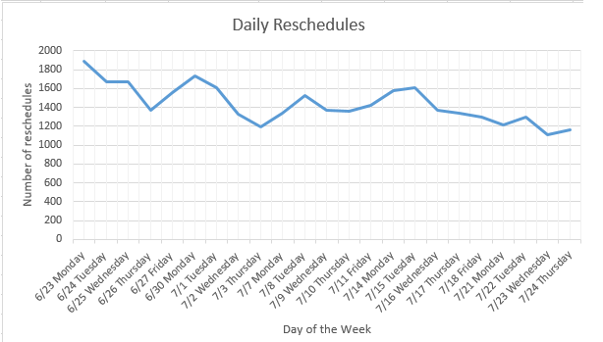

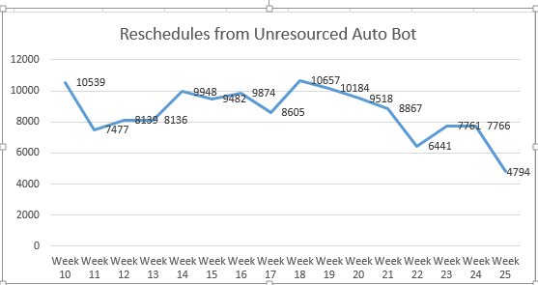

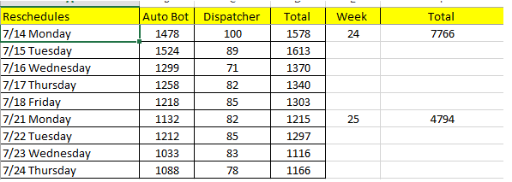

# Hiring (Rebecca)

### Key Metrics

* **Techs started:** 20 this week (July avg = 17/week vs 14/week in June; Q2 weekly avg ≈ 14)
* **Starts cleared for next week:** 19 (week of Jul 28)
* **Pipeline: 30 in final steps for week of Aug 4**; 9 for week of Aug 11 (and growing)
* **Offers extended:** 26 this week
* **Interviews: 70** completed through Fri, Jul 25 (up from ~48 weekly avg)
* **Funnel targets to hit 30 hires/week:**
  + Interviews/week: **99** (48 avg; 70 this week to date)
  + Offers/week: **36** (currently averaging 29)
* **July month-to-date:** 68 tech starts (85% of 80 goal)
* **Q2 total:** 168 tech starts (84% of 200 goal) — pending final Jul 26 updates

What Got Done This Week

* Delivered 20 new tech hires; cleared 19 to start next week
* Logged 70 interviews (highest single-week total in FY25), driven by Joy Bot 2.0 launch
* Extended 26 offers
* Met with Legal (Malory), HR/Systems (Aimee, Sandy) on NC Works OJT agreement; sent follow-up questions to NC Works to enable August pilot. Frankie to chase if no response.
* Launched Airtable recruiting scorecard; stood up base schema to aggregate recruiter KPIs and touchpoints across all systems; iterative build underway

### Next Week’s Targets

* Drive funnel volume: Reach 75+ interviews next week on path to 99/week
* Offers: Maintain 36+ technician offers for the week to feed Aug/Sep cohorts
* Joy Bot 2.0 scale: Continue to push additional leads in top-need markets and report conversion
* NC Works pilot: Secure answers, finalize participation agreement, and green-light August launch; escalate if no reply
* Airtable scorecard v1: Ship recruiter dashboard with core KPIs (screens, interviews, offers, starts by recruiter/market) and weekly auto-refresh

# Local Demand Gen (Deep)

### **Key Metrics**

|  |  |  |  |  |
| --- | --- | --- | --- | --- |
| **Market** | **Creates This Week** | **WoW Change** | **Completes This Week** | **Completion %** |
| Miami | 479 | +11% | 331 | 69% |
| Orlando | 233 | -5% | 157 | 67% |
| Puerto Rico | 482 | -2% | 319 | 66% |

**Observations:**

* Miami saw healthy growth in creates (+11% WoW) and improvement in completions.
* Orlando and Puerto Rico saw slight WoW create declines (-5% and -2%, respectively), but maintained stable completion rates.

### **What We Accomplished This Week**

#### **(1) Marketplace Optimization**

* Opened ~60 slightly constrained markets to receive incremental demand this week.
* Maintained overall major pullback mode with close monitoring of outcomes.
* Collaborating closely with Rafael to transition manual list management into Tableau, capturing recent operational decisions and variables, enabling a streamlined process and change-log capability for August implementations.

#### **(2) Email Marketing Localization Test**

* Published experiment report detailing results of localization A/B tests.
* Key findings indicate:
  + "From" field localization significantly lifted unique click-through rate (+35%) and creates (+163%), though no impact on open rates.
  + Subject line localization improved unique open rates (+1.5%) but didn't meaningfully drive downstream engagement.
* **Recommendation**: Adopt "From" field localization as a standard for all future email marketing campaigns due to clear downstream conversion benefits. Subject line localization recommended only selectively for awareness and top-of-funnel campaignsExperiment Report - Em….

#### **(3) Local Tactics**

* **Direct Mail Initiative**: Finalizing creative designs with William and Todd. Vendor quotes expected soon, moving towards final proposal presentation next week.
* **BYOV Vehicle Magnets**: Vendor selection finalized, logistical execution underway. Carl providing technician list; magnets expected in technician hands by early August.
* **Leave-Behind Fridge Magnets**: Strategy updated from incentive-based to mandatory. Productive sessions with Sharon and Jeff completed; launching pilot in Dallas (and possibly Houston/Atlanta). Pilot to test and refine distribution process prior to national rollout.
* **Email Marketing A/B Test**: Completed with significant results (see above section). Implementation recommended and approved for permanent business practice.
* **BigEye Agency Engagement**: Confirmed decision to pause engagement until fall. Improved second presentation noted, but internal capabilities will be tested and evaluated before committing to external agency resources.

#### **(4) Product Operations**

* **WhatsApp Servana Bot**:
  + Decision made to conduct QA and UAT in the production environment due to testing server reliability concerns. Soft-launch targeted next week, prioritizing Spanish-language booking flows.
  + Staged ramp-up planned following internal testing and monitoring. Marketing budget and paid social promotions finalized for gradual, controlled rollout.
* **Diagnostic Fee Experiment (Web Funnel)**:
  + Variant skipping diagnostic fee consent step continues to strongly outperform control and copy-change variants in conversion metrics (34% conversion vs. 30% control).
  + Upcoming detailed analysis on downstream creates, cancellations, and payment disputes to ensure no adverse impact before rolling out to 100% of users.

#### **(5) Product & Marketing Q3/Q4 Brainstorming Session**

* Coordinating with Jenny, Patrick, and Jesse on an upcoming planning summit.
* Objective: Identify and prioritize marketing-driven product tests, enhancements, and initiatives for second half of 2025.
* Aim: Develop a flexible but comprehensive roadmap that aligns marketing needs with product development priorities and capacity.

### **Next Week**

* Monitor and review initial results from newly opened marketplace optimization markets.
* Finalize direct mail creative and vendor selection; submit proposal to leadership.
* Finalize BYOV vehicle magnets logistics for early August distribution.
* Initiate fridge magnet leave-behind pilot program and refine operational plans based on feedback.
* Complete WhatsApp Servana Bot internal testing; initiate staged external marketing launch.
* Begin downstream analysis for Diagnostic Fee Web Funnel Experiment to support broader rollout decision.
* Conduct Product & Marketing brainstorming session to solidify Q3/Q4 strategic product initiatives.

# Learning and Development (Sharon)

Key Metrics

* **New Hire Days-to-Route (**[**Tableau New-Hire Dashboard**](https://prod-useast-a.online.tableau.com/#/site/transformcoservices/views/SHSW2RoadReadinessDashboard/W2TechRoadReady?:iid=1)**) 0-120 Days**
  + *Home Appliance / Full-REF Generalists* – 26 calendar days (No Change); 22 business days (No Change)
  + *HVAC* – 21 calendar days (+5) - this is due to an increase in HVAC techs to road
  + Avg. Days-to-Route by hire type: Experienced (**32**) – 23 days; Green (**16**) – 33 days (+2); Transferable (**48**) – 27.0 days (+4)
* **Onboarding Funnel (0-120 days)**
  + 199 employees in funnel (+22 WoW)
    - 96 on route (+12); Includes +3 HVAC to Route
    - 39 in mentorship
    - 35 in online learning
    - 29 Lost to attrition (+3) (15% Rate within current pipeline) (+2%)
    - 44 Green REF techs trained (Same); 26 on route (+1), avg days to route 30 (+2 days)
  + 67 (+16) Techs moved to 120+ Days (out of funnel)
* **Cross-Training & Performance**
  + Individual Requests:
    - 29 Incoming Requests (+8)
    - 8 To Be Scheduled (+4)
    - 9 Scheduled (+9)
    - 7 in training (+2)
    - 26 Completed (No change)

### **What We Accomplished This Week**

**Field Communication & Engagement (Jeff & Sharon)**

* **Impact**: Developed content to strengthen technician understanding of upcoming changes or existing procedures.
* **How**: Drafted field communications for information or upcoming initiatives including:
  + [IHR Newsletter](https://shs-techhub-help.s3.amazonaws.com/Field+Tech+Communications/files/In+Home+Repair+News+-+07_21_25.pdf)
  + [Tech Spotlight](https://shs-techhub-help.s3.us-east-1.amazonaws.com/Field+Tech+Communications/TechnicianSpotlight/files/Technician+Spotlight+-+07_24_25.pdf)
  + [7-21 Podcast with Samantha](https://shspod.replit.app/episode/ce5a28a2-5703-4080-82ec-6576b765f4ba?source=share) (I wasn’t succinct so Sharon needed to break it up into 3 parts)
  + Key Comm Prep This Week:
    - **Workday Launch** - Text notifications sent to all technicians who will be part of the Workday transition on 7/27, and message to be included in 7/28 newsletter.
    - **Meal Violation Process** - Prepared communication scheduled for inclusion in 7/28 newsletter (pending final approval from Malory)
    - **CSAT Perfect Scores YTD** - Included communication in the 7/24 Technician Spotlight
    - **Success Signals: Specific Coaching Language** – reviewed four different coaching escalations including lunch punch, cancels after 10 minutes, end of day punches, and punch location and provided suggestions to Nicole’s team for changes/edits.
    - **SOP Reviews** – reviewed and edited SOPs on the new truck stock replit and the cancel after 10 minute SOP and shared with Nicole’s team.
    - **Fridge Magnet Program** – supported William Leonard and Deep Grewal on a strategy and communication plan for the program.

**Cross Training (Sharon, Chris, JP, and Nate):**

* **Impact: Cross-train technicians to create improved coverage, impacting revenue and profit, per last week’s analysis that outlined a median increase of +40k per tech over a 52 week period. Also supporting the retention of technicians who agree to cross-train**
* **How**:
  + Scheduled 9 additional techs for cross-training including managing the logistics of mentorships and online education.
  + Managed 7 currently in cross-training.
  + There is an HA tech that will be cross-trained into HVAC and we will watch this experience closely to see success.

**New Hire Training (Entire Team – Jeff, Sharon, Nate, JP and Chris)**

* **Impact:** Effective, streamlined new hire training gets techs to the road quickly but effectively with improved retention.
* **How:** 
  + Continued Building a mentorship program via replit to support mentorship automations, including communication, scheduling, and feedback management. Attained Snowflake access this week to connect data.
  + Started reviewing new hire stats to check alignment with KoyFin data.
  + Reaching out to Tech Supervisors who have not been recertified as mentors to re-do the coursework to align with new expectations and requirements.
  + Built a document clearly outlining pay expectations for mentors to put into the Mentor Certification course
  + Worked with Rebecca/Recruiting to share stats on green/transferable hires for the board presentation.
  + Workday- Final launch meetings and communication.
  + Managed employment concerns regarding two technicians and discussed building a policy with Crystal Cash to include expectations of managing performance issues in the first 120 days.
  + Built the first draft of a Sealed System School proposal to review with team and then leadership

**Compensation Strategy & Feedback Integration (Jeff)**

* **Impact**: Advanced compensation redesign by validating models with performance data and field input, improving alignment with technician outcomes.
* **How**:
* Requested Virender to recalculate backtest performance data using the updated streak requirement (2 SPHW and 4 PM per month). Updated analysis was sent to Jeff Grossberg on 7/25 for review by Sears Protect Finance and Katrina to inform final streak qualification recommendations.

**Segno Workflow & Reporting Enhancements (Jeff)**

* **Impact**: This week’s efforts collectively streamline technician-facing systems, improve data accuracy, and support fair, transparent processes—driving efficiency, trust, and a more consistent field experience.
* **How**:
  + **PowerPay Trainee Earnings View:** QA review of the PowerPay Trainee view was approved pending addition of incentive and commission details. A 7/25 request to enable SPHW and PM commissions during training will require further review. Follow-up scheduled for 7/30 to assess needed updates to distinguish actual vs. projected earnings.
  + **BYOV Approval (Mileage) Automation:** Met with Crystal to align on renaming the Segno Sears Drive module to support BYOV messaging; mock-up drafted for updated process docs. Will deliver requirements to Shyam for CA and IL BYOV reimbursement rates.
  + In parallel, Rocco and Aly identified a discrepancy between Segno and Google API mileage calculations. Segno team will review source data; alignment meeting set for 7/29. Pending resolution, updated mileage logic automation is targeted for 8/1.
  + **Meal-Violation Logic:** On July 23, remaining launch dependencies for the Meal Violation module were reviewed with Crystal. The exception feature will be deferred to phase 2 to avoid delaying the August 1 launch. Communication is planned for the July 28 newsletter. Final process doc and notification verbiage pending from Crystal.

Next Week

1. Work with Crystal to align on expectations of Tech Supervisors for cross-training; create a plan for reach out to single-skilled tech supervisors to request cross-training into generalists
2. Work with Anushri to get final information needed from report to enroll identified techs into the Multiple Attempts online training program
3. Finalize the Sealed System School proposal and get clarity on the investment working with Randall Bishop.
4. Enable PowerPay trainee technicians to be eligible for SPHW and PM commissions during their training period. In parallel, provide a revision the PowerPay Trainee Profile QA view to reflect this change and clearly distinguish between actual earnings and projected sample earnings to ensure clarity for trainees.
5. Finalize the communication plan and business requirements for the Meal Violation module in Segno Workflow in preparation for the scheduled launch on August 4.

Technician and Corp Talent (Crystal)

**What we accomplished this week**

**Streamlining Compensation Modeling & Job Architecture (Owner: Larry)**

1. Refining the Commission Model for Call Center Repair Sales Agents  
    Larry partnered with Brandon Spaeth to refine a commission structure for MSO Call Center Repair Sales Agents, aiming to align incentives with their evolving roles. As automation reduces inbound volume and increases escalated call complexity, the updated model ties compensation to cash call conversions and Sears Protect Home Warranty (SPHW) enrollments.

* Problem Solved: Misalignment between current compensation and job complexity/volume changes due to automation.  
   Impact: More equitable compensation structure that motivates high-value call handling, with proposed tweaks headed to MV review next week.

1. Compa Ratio & Market Alignment Analysis  
    Larry conducted a compa ratio assessment to determine the competitiveness of internal salary grades versus market benchmarks. Findings: Current average exempt associate pay is 106.68% of grade midpoint; under the proposed model, this shifts to 91.88%.

* Problem Solved: Potential overpayment relative to market and grade structures.  
   Impact: Enables market-aligned pay ranges, promoting fair pay and budget optimization across roles.

1. Job Architecture Clean-up & Exemption Review  
    Larry initiated a broad review of company Job Descriptions and Job Codes, identifying:

* Job Codes with no headcount in 3+ years (candidates for deactivation)
* Descriptions outdated by 5+ years or missing
* Roles under $60k needing FLSA exemption review
  + Problem Solved: Outdated or irrelevant job data cluttering systems and risking compliance gaps.  
     Impact: More accurate job architecture, reduced audit risk, and improved talent/pay management frameworks.

1. Technician Contest Launch Preparation  
    Larry collaborated with Jeff Grossberg, Brent, and others on launching a Technician-based team contest to drive SPHW enrollments in August.

* Problem Solved: Need to motivate field adoption of SPHW sales efforts.  
   Impact: Reinforces tech engagement and enrollment growth via gamified participation. Rules and legal coordination are in motion.

1. Pay Review Process Optimization  
    Reviewed 12 technician pay increase requests based on performance, market benchmarks, routable skills, and peer comparisons.

* Problem Solved: Disparate or reactive pay decisions.  
   Impact: Structured weekly cadence enhances fairness, transparency, and retention alignment.

1. Automating Job Description Uploads to PeopleSoft  
    Larry developed a Replit-based automation bot that converts Word Job Descriptions into the Excel template required for PeopleSoft.

* Problem Solved: Manual formatting and upload inefficiencies.  
   Impact: Significant time savings in HR operations; bot adapts to various formats and improves mapping accuracy over time. Refinement will continue next week.

**Compliance, Automation & Union Alignment Enhancements (Owner: Hannah)**

1. Labor Agreement Review for External Hiring  
    Hannah completed a comprehensive review of collective bargaining agreement (CBA) provisions impacting external hiring. She analyzed clauses around internal promotion prioritization, seniority, and notification procedures, which will now inform future hiring practices.

* Problem Solved: Risk of violating union protocol during external hiring cycles.  
  Impact: Ensures union compliance and smooth HR alignment in talent acquisition efforts moving forward.

1. Support for Puerto Rico UI Claims  
    Provided hands-on support in processing Puerto Rico unemployment insurance claims, including eligibility verification and resolution tracking.

* Problem Solved: Backlog and inconsistencies in regional UI claim submissions.  
   Impact: Streamlined resolution cycles, better compliance, and improved cross-functional support between HR and local operations.

1. Ongoing Driver & Employment Compliance  
    Hannah maintained her weekly cadence on:

* I-9 verification outreach for new and expiring employee records
* Motor Vehicle Record (MVR) validation for field technicians
  + Problem Solved: Risk of expired compliance documentation.  
     Impact: Maintains regulatory integrity and reduces potential legal exposure.

1. SHSAI Bot Enhancements & Automation  
    Working with Benji and Gracer, Hannah enhanced SHSAI’s capability to respond to LOA inquiries by uploading new return-to-work documentation.

* Problem Solved: HR bandwidth consumed by repetitive LOA questions.  
   Impact: Empowers techs with real-time answers while reducing HR manual workload.

1. Launches & Progress on Automation Tools

* LOA Bot: Now fully live. Refinements underway based on internal feedback
* CA Meal Penalty Bot: Tracks meal penalty compliance daily and shares reports automatically
* Classet Voice Review Bot: Initiated parallel bot for 30/60/90-day reviews. Voice delivery and storage logistics are in early stages
* Punch Compliance Bot: Structure built and logic reviewed with Crystal’s input; aiming to launch next week
  + Problem Solved: Time-consuming compliance and feedback workflows.  
     Impact: Reduces manual oversight, ensures faster policy adherence, and scales associate performance feedback loops.

1. Onboarding & Orientation Improvements  
   Migrated New Hire Orientation decks from TransformCo to IHS branding. Embedded SHSAI training modules to drive early tech adoption of automation tools.

* Problem Solved: Branding and training misalignment.  
   Impact: Better early-stage associate onboarding and clarity on tool usage.

1. Union Collaboration & District Support  
   Announced a returning technician and a promotion to HA Tech, reflecting staffing progress. Continued to foster trust with District 7323 and rolled out SHSAI adoption in Detroit and St. Louis. Reinforced cross-district consistency in HR and operational processes.

* Problem Solved: Fragmented union relations and inconsistent tech enablement.  
   Impact: Promotes retention, unified field operations, and deeper adoption of automation in union-supported regions.

**Tech Engagement, Labor Research & Associate Relations Oversight (Owner: Brent)**

1. Tech Engagement & Retention Strategy  
    Brent continued his push on workforce engagement by:

* Driving participation in the Technician Engagement Survey up to 55%
* Preparing the upcoming Week 26 survey
* Using AI tools to create a YTD HVAC attrition analysis, presented on Friday
* Reviewed daily Temperature Survey feedback, routing actionable technician comments to managers
  + Problem Solved: Low participation and lack of actionable insight into technician morale and attrition.  
     Impact: Better real-time visibility into tech sentiment and attrition trends, enabling targeted intervention and improved retention.

1. Rewards Program Evaluation  
    Led follow-up with the Shop Your Way (SYW) team on a potential rewards and recognition platform.
2. Performance Management: Technician Supervisor Skill Mapping  
    To advance the goal of having all IH Technician Supervisors become full generalists, Brent used AI tools to:

* Audit current skill coverage across 157 supervisors
* Identify gaps to full generalist status:
  + 52 are full generalists
  + 40 have 4 skills
  + 15 have 3 skills
  + 13 have 2 skills
  + 37 have 1 skill
* Problem Solved: No centralized visibility into supervisor skill readiness.  
  Impact: Provides clear roadmap for upskilling and career development planning to support operational flexibility.

1. Associate Relations & Investigations  
   Supported at least eight associate relations cases, including attendance, substance-related issues, MVR compliance, job abandonment, pay disputes, and performance concerns.

* Problem Solved: Complex personnel issues that risked compliance and morale.  
   Impact: Reinforced accountability and supported fair treatment through prompt and structured resolution pathways.

1. CBA Research: External Interviewing Practices  
    In coordination with labor stakeholders, Brent reviewed five CBAs and found no restrictions regarding external candidate interview procedures.

* Problem Solved: Uncertainty around legality of consistent hiring processes in unionized regions.  
  Impact: Opened the door to standardize external interview protocols across union and non-union districts, pending final discussions.

1. Punch Correction Investigation  
    Assisted HR Ops in addressing irregular punch correction behavior. Investigation revealed no misconduct; technician was reminded to only make edits when necessary.

* Problem Solved: Potential abuse or misunderstanding of punch-editing protocol.  
   Impact: Reinforces timecard integrity and reduces administrative burden caused by improper edits.

**Automated Tech Pay System, Compliance Processes & Team Structuring (Owner: Crystal)**

1. Automated Tech Pay Retention Review System  
   Crystal led the development of a comprehensive bot-driven Pay Analysis & Retention Review system. This tool centralizes technician pay data, integrates performance metrics, and automates pay and retention decisions.

Key Features:

* Pay percentile calculations by role and geography
* Market rate comparisons and peer equity checks
* Performance-based pay adjustment recommendations
* Automated email workflows to HR
* Secure, role-based access and authentication
* Skill/certification tracking and promotion readiness insights
  + Problem Solved: Time-intensive, manual pay review cycles with limited consistency or data visibility.  
     Impact: Transforms retention management into a data-driven, automated process, reducing HR cycle time, improving fairness, and highlighting strategic career advancement opportunities.

1. Meal Violation Automation & Disciplinary Framework  
    Crystal collaborated with Jeff on the meal violation automation tool, drafted communications, created a disciplinary policy approved by Malory, and integrated it into the automation loop.

* Problem Solved: Untracked or inconsistently handled meal break violations.  
   Impact: Standardizes policy enforcement and aligns disciplinary processes with automation to ensure compliance and transparency.

1. Tech Supervisor Mapping & Team Sizing Strategy  
    Created a Google Map of all technicians and supervisors, and transitioned Tech-to-Tech Sup mapping to Carlos.

* Problem Solved: Lack of scalable structure for Tech Sup assignments.  
   Impact: Ensures geographic alignment, improves supervision quality, and supports workload balancing.

1. Policy Updates & Operational Enablement  
    Updated the BYOV policy to allow CA and IL techs to enroll. Developed and obtained Malory’s approval for a Company-Issued Phone Policy to ensure automation-related texts are only reviewed while on the clock.

* Problem Solved: Policy misalignment and risk exposure from techs engaging with automated tools off the clock.  
   Impact: Strengthens labor compliance and ensures clean tech enablement under controlled conditions.

**Next Week Targets**

* Enhance Tech Pay Retention Review System to:
  + Proactively flag retention-risk technicians
  + Enable automated email notifications
* Continue progress on:
  + Unpaid time off and attendance policy automation
  + Workday Wave 3 Go-Live: Rollout to 35 locations / 830 techs on Sunday, July 27
  + Apply configuration updates for unpaid time off
* Finalize engagement strategy follow-ups based on Week 26 survey
* Continue associate relations investigations
* Continue generalist development tracking
* Launch Punch Compliance Bot
* Continue SHSAI enhancements and district alignment
* Continue onboarding compliance across regions (I-9s and MVRs)
* Finalize comp model and grading structure for MV review
* Finalize SPHW contest rules with Legal
* Advance compa ratio and pay curve modeling
* Continue job description updates and job code deactivations

**Supply Chain & Sourcing (Karen)**

### **Key Metrics (FY Week 202523)**

* **Negotiated 2025 Savings (YTD):** $17.60M
* **Annualized Savings Run Rate:** $21.55M
* **Same Day Ship %:** 65.1% (vs. 60.0% prior week)
* **Order to Delivery Cycle Time:** 3.75 days (vs. 4.62 days prior week)
* **Average Days to Ship:** 1.70 days (vs. 2.21 prior week)
* **Average Days in Transit:** 2.04 days (vs. 2.41 prior week)

### **What Got Done This Week**

#### **Marcone Returns Program Expansion**

* Launched the Part Return vendor diversion program 7/17 targeting 30% of all Good Condition returns from Manteno and PartsDirect to Marcone. Actual diverted return % 34%
* BOY Savings: $3.31M
* Annualized Benefit: $5.56M
* Effective: 7/17/25

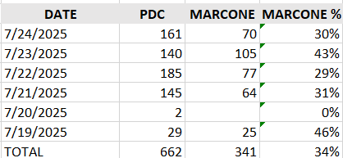

#### **Manteno Wind Down**

* Manteno Inventory $4.6M, down $80k WOW driven by lower returns driven by the diversion to Marcone.
* Created report to identify transactions where inventory existed in Manteno but order routed to vendor. Reviewed several examples with MSE & PSC Product Teams.
  + Turned off Truck Replenishment Use1 Get 1 Automated job which wasn’t checking Manteno inventory before parking orders which was putting available inventory on hold i.e. order for 10 pcs may come in but Manteno only had 2 so it holds the 2 to fill the order. These orders were being cleared out every 3 days but in the meantime, customer orders were diverted to vendors. Job was stopped 7/25
  + Abhinav following up on 2 examples where inventory was in Manteno but vendor was selected. Follow up due 7/28 on findings & action.
  + 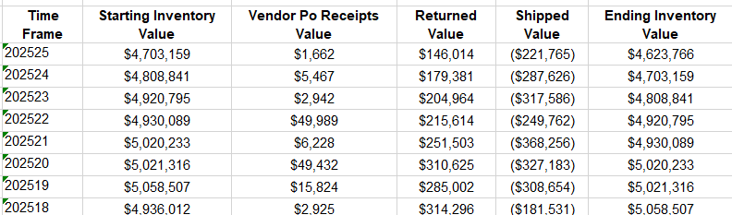

#### **FSSL Financial Evaluation**

* Objective: Determine economics for each branch / mobile location to determine go forward strategy and selection by site. Key factors evaluate include – Incremental Tech Drive Time, Part Runner Payroll, Premium costs for drop ship (freight) vs. Higher COGS for some FSSL Locations i.e. Tribles & cycle time. Time setup to review with me (Samantha) and Andrei 7/28 to review model

#### [**Estimated Arrival Date (EAD) System Overhaul**](https://searshs.monday.com/boards/7404187760/pulses/9617363445)

**Manteno EAD Accuracy Improvement** was set at 9.4 days plus Tech Hub was adding another 3 day buffer for the initial service date. 20% of the parts come from Manteno so on 20% of the SO the earliest date we would schedule was 12.4 days. I reviewed the Logs with Yuwen and Gabe's team and determined that there were Global settings to add 3 days in 2021 as well as another 3 days added in Oct of 2024 to the Tech Hub setting. Since those settings, Supply Chain has drastically improved the order to delivery cycle time. Those settings were removed 7/18. Now service is set based on 4.9 days plus Tech Hub adds 1 day to the earliest service order date. These changes are reducing reschedules (potential pull forwards) on 20% of customer orders.

**Timely Delivered Status -** Reviewed logs for Encompass orders and found that 8 of 11 orders were delivered on the EAD. However, Encompass is updating their API with delivery status overnight so we receive the update the following day which marks it late in our system. **7/28 launching a direct API connection to FedEx** to update the delivery information which will mark the items delivered timely for a more accurate report.

**Improved EAD data logged in Database** - Wk 3, 100% of API sources have EADs logged in PDCC database (source of report), up from 98% prior week.

**Next steps:**

* Confirm **FedEx API** connection works 7/29 & trace updates through logs & verify improvements in delivery timing in report. Update frequency every 90 min
* Map vendor estimated delivery date to PDCC field to update - Yuwen's PSC team.
* Finish SOM work (Molly's team) to add field for vendor delivery date & review logic for reschedules to outline how to use additional data available for more accurate reschedules
* [@John Childres](https://searshs.monday.com/users/53219823-john-childres) with Gabe's team - continue to review examples of late deliveries for system / operational opportunities
* [@Philip Hsueh](https://searshs.monday.com/users/56861037-philip-hsueh) report enhancements to have additional "On Time" measure that takes +/- 1 day vs. EAD and tracks over time
* [Report detail](https://prod-useast-a.online.tableau.com/#/site/transformcoservices/views/partdeliveryaccuracy/Partdeliveryaccuracy-EAD?:iid=2)

### **Next Week’s Targets**

* Deploy **FedEx API** which will provide more timely and comprehensive delivery updates – Finalize PDCC integration (ETA 7/28)
* **EAD field in SOM submission** – Release and validate new order logic (ETA 7/28)
* **Proactive ship risk notification** – Review Marcone & Encompass ship risk automation following API updates 7/29
* **Vendor returns expansion** – roll out Phase 2 which is cross vendor returns which enables return to Marcone even if that part came from another vendor as long as we have purchased that SKU from Marcone in prior 60 days.
* **Parts Q3 Road Map** – Financially Size & Prioritize major initiatives with Gabe
* **Return Task Approval Automation:**
  + Complete data ingestion into Snowflake and validate record accuracy with Victor by Wednesday, July 30.
  + Build logic for “if X then Y” automated approvals/rejections; first rule set draft due Friday, August 1.
  + Design daily/weekly/monthly reporting cadence for automated updates; review cadence with Karen for sign-off by 8/1.

# Inventory & Field Enablement (Tim Michael)

### **KEY METRICS**

* **Parts Unaccounted for – beat the financial plan**
  + MTD Forecast - **$182,700 –** ($141,947) better than plan & $41,151 higher than last wk.
    - In Home: $0.112M | Parts Direct: $0.054M | PDC: $0.016M
  + **Reduce Excess and Obsolescence Reserve by 50% in 2025**
  + Current: $3.0mm | Target: $1.7mm | $1.7mm short of plan | (*$0.198M*) decrease to the reserve GL account expected for end of July
* **Optimize Truck Stock**
  + TSSL: Achieve 20% Truck Stock Service Level
    - Current: 15.0% | Target: 20% | 2,938 completes w. trk stk – 19,559 completes that used parts – 973 below the 20% goal
    - Truck stock saved $0.249mm effective cost in additional trips this month
  + Right Size Truck Stock
    - $7.5mm *(261k pcs)* >>> Target: $1.7mm (*55k pcs*)
    - 61k Deletes on active trucks $2.0M (*plus 62k on spares - $2.3M*)
    - **ASD Tasks:** 7,623 Assortment Delete tasks open- 746 techs
    - **NNP Parts:** 800 pending unused parts to return- 358 active trucks
  + Manage Truck Out of Stocks to less than 10%
    - FSSL: 23.3% | Target: <10% |
    - Non-FSSL: 15% | Target: <10% |
  + FSSL Truck Needs filled from FSSL Vendors
    - Current: 89.1% | Target: 100% |
* **Sell through returned, non-stocked SKUs in Manteno**
  + Current: $0.776mm | Target: $1mm | $3.7mm of non-stocked parts on hand to sell

### WHAT WE ACCOMPLISHED THIS WEEK

**Parts Unaccounted for** – **on track to beat July plan by $0.14M for SHS and by $0.16M for In Home Repair! $1.13 CPC vs plan of $2.23 CPC**

* Control Board Recovery Project
  + Round 1 & 2 completed in May, June respectively
  + Round 3 in July
  + A screenshot of a data sheet

    AI-generated content may be incorrect.
* Encompass Purchase Order approved, and payment made, visiting the facility next week in Atlanta to review the project for long term sustainability

**Drop Ship to COGS Project – (***Amit Arora, Gabe Cloutier, Timothy Michael***)**

* *Recap meeting with NetSuite ACS – designed test scenarios and deployed to Gabe Cloutier to test in Sandbox*
* *Amit Arora sent design requirements and reviewed with Gabe Cloutier*
* *Designed and deployed a new Adaptive refreshable, GL Trial Balance for Inventory -* [*LINK*](https://searshc.sharepoint.com/:x:/s/CloseWeekInventoryControlGroup-PublicShareFiles/EYuKogsclrdOh0Wt8e1MBsMBHtjJxtsjxHk6hdAuCcX51Q?e=9Ysx6c)
* ***NetSuite ACS*** *– script and Drop Ship PO is deployed in Sandbox -* [*LINK*](https://searshc.sharepoint.com/:f:/s/SupplyChainProcessDocumentControl/EtniO03kCHJBm3QKxrDQGyUBIC-VWKfS7NhjhWnvcbkQZg?e=XGTXHX)
* *UAT testing with Gabe Cloutier’s team for FW25*
* *Expected production launch by the end of July FW30*

**Right Size Truck Stock -** (*Tim Motard, Oscar Santana, Goutami Walsang*)

* Project transitioned from Tim Motard to Clara Gonzalez – Reviewed on 7-22
* 2,626 assortment deletion tasks completed during Fiscal Week 24
* *412 new ASD tasks created in Fiscal Week 24*

***NetSuite – Planning and Budgeting*** *–*

* *The NSPB project has been discontinued due to unnecessary complexity and design overhead*
* *A meeting is scheduled for Fiscal Week 26 with NetSuite to evaluate optimal use of the NetSuite Warehouse Management System (WMS)*
* *This review will focus on leveraging WMS capabilities to forecast truck stock needs and identify a streamlined alternative to NSPB*

**Vendor Payments and Invoicing – Complete Inbound LPN Billing Pre-audit prior to payment** (*Jackie Bigley, Stephen Wong*)

* Handoff of this team and Vendor Payments to Amit Arora – Transformco Accounting

# FLEET Optimization (Tim Emery)

### **NEXT WEEK’S TARGETS**

* **Parts Unaccounted for** – beat July target/plan of $324,647 –
* **Organizational Alignment** – Dashboard and KPI reviews with leaders in Fleet, Assets, Inventory and Analytics teams – establish daily, weekly metrics that clearly identify wins and losses

## Key Metrics

### Fleet Cost Reductions

**Vehicle Sales**

* Goal: 65 per month ($100,000 net sales)
* Current: 88 MTD ($121.231)

**Aged Rental Reductions (<14 days)**

* Goal: zero over 30 days and average less <14 days
* Current: 65 over 30 days and 18.63 avg.

### Spare Fleet Management

**Eyes on All Vehicles**

* Goal: 100% visibility
* Current: 86% via Samsara; 99.8% known inventory

**Cost-Effective Spare Fleet Storage**

* Goal: 95% free storage
* Current: 11% (based on 250 spares)

**New Hire Vehicle Issuance**

* Goal: 100% issued within 3 weeks
* Current: 87%

### Fleet Health Management

**Mobile Preventative Maintenance**

* Goal: 40% of assigned fleet
* Current: 0% (Negotiating new deal with Wrench and Goodyear)

**Samsara Telematics Integration**

* Goal: Q4 integration into AMS
* Current: AMS rebuild in progress

## Completed This Week

### Fleet Cost Reductions

* 16 vehicles sold — Total: $19,660
* 12 rental contracts >14 days closed

### Spare Fleet Management

* 4 vehicles without address under investigation
* 20 new hire vehicles in process

### Fleet Health

* Goodyear mobile maintenance pilot training/demo 7/29
* Meeting with Wrench mobile services mini RFP in progress

## Additional Fleet Projects

### Fleet Process & Reporting Automation

* End to End truck assignment multi-departmental tracking and notification system PRD initiated
* Truck Maintenance punch process change. (PRD submitted and SOP drafted)
* Rental Data extraction and Tableau report outlined with PRD submitted through SCA
* Ongoing analysis on Fleet Insurance & Burn Rate — updates shared with Andy Dworkin and Eddie

### Additional Initiatives

* 3rd Pilot group with cards rolling 7/28 — 379 Technicians added to Coast Fleet fuel card
* Coast debriefing, debugging and program improvements submitted
* Decommission Plan Finalized — 189 vehicles targeted for “Declined Repairs” and part removal provided to Parts/Inventory
* Pep Boys reserve fleet “Vehicle Condition Report” in development
* Streamline SHSAI/Benji AI scheduling and tech monitoring with Org change
* Internal Fleet Administrator 800# — Service advisor communication portal in development

Equipment & Supply Operations (Bob)

**Key Metrics**

**Lost Tool Cost Reduction**

* FY24 Baseline: $65,986
* FY25 Goal: $15,000
* Progress:
  + June YTD: $9,953
  + July MTD: $1,709

**What We Accomplished This Week**

**Onboarding & Training**

* Completed onboarding for 20 new hires, 10 return from LOA, and 1 HVAC Installer
* Prepared full onboarding kits (tools, phones, uniforms) for 22 new hires scheduled to start next week.

**Tool/Supply Inventory Management**

* Completed vendor interviews for refrigerant RFP
  + Lowest cost vendor updated bid with a 9% decrease and a 3 year price lock on 3 refrigerants

**Automation Planning**

* Supply Ordering Automation
  + Abhinav has reported that the team is currently facing a resource crunch. During their Q3 planning session held yesterday, it was concluded that the Segno integration with Multisourcing can be scheduled for development starting in September 2025. The estimated effort for implementation is 3 weeks, with a projected completion date of September 30, 2025.
  + To address the potential delay and ensure business continuity, I have escalated the priority of this project. Additionally, we are exploring possible interim solutions that could mitigate the impact during the waiting period before development begins.
* Refrigerant Ordering Automation
  + Waiting for 148 techs to complete refrigerant inventory, Nicole is taking action. Worked with Matt Savery and Mandy Lacks and identified HVAC techs that are not accurately entering refrigerant used on service orders, they are entering .01 ounce as amount used for every repair. Provided detail to Alex who will follow-up. ETA: 8/22.

**Refrigerant Invoice Processing** **& Vendor RFP**

* Completed vendor interviews for refrigerant RFP
* Lowest cost vendor updated bid with a 9% decrease and a 3 year price lock on 3 refrigerants

**Next Week’s Targets**

**Tool Inventory Management**

* Update Uniform and Badge reporting to include average life of orders
  + Begin using to track progress

**Automation Planning**

* Review with Tim and escalate the priority of this project. Additionally, explore possible interim solutions that could mitigate the impact during the waiting period before development begins

**Refrigerant RFP, Ordering Process, and Contract Process**

* Review of updated refrigerant vendor bids, goal is to make offer by EOW.
* Begin preparation of CapCon presentation.

# Parts Management (Matt Savery)

**Key Metrics**

**Active Technician Non-Compliance Tasks**  
 • Current total (as of 7/25/25): 7,422  
   • Returns: 5,627   
  • Receives: 1,795  
 • Weekly target (ending 8/1/25): 6,747

**2025 Inventory Task Completion**  
 • Completed: 761 out of 2,310 (32.94%)   
  • Decommission: 337  
   • Full Count: 189  
   • Re-assorts: 38  
   • Deactivated: 197

**Return Task Approvals (RTAs)**   
• <14 Days: 1,807 Tasks, $109,744  
 • 14–21 Days: 953 Tasks, $55,796

**What we accomplished this week:**

**RTA Automation redirect:**

* Launched automation to accelerate processing of parts flagged missing or damaged by technicians, reducing manual work and resolution delays.
* Consolidated Return Task Approval data from three sources to streamline analysis and reporting.
* data rebuild began to restore visibility into occurrences, dollar values, and exception types, enabling faster and more accurate decisions.

**EAD and Vendor Return abnormally Automation:**

* Built an automated Replit dashboard to track daily operational metrics, detect anomalies, and flag potential systemic failures.
* Defined initial outlier thresholds based on historical data to enable early anomaly detection.
* Planned integration with Monday.com for automated reporting and real‑time stakeholder notifications.

**FSSL Cost Analysis**

* Met with Satish and Philip to share detailed cost data on part runners tied to mobile hub operations.
* Identified top cost drivers (route overlap, idle time, and underutilized hubs) for immediate analysis.
* Agreed on next step: evaluate route consolidation options using current week’s expense data.

**Onboarded new team members**

* Met with Sanjun and Al to review active automation initiatives and clarify ownership of current projects.
* Identified key gaps affecting data accuracy and structural alignment across workflows.
* Agreed on immediate actions to address gaps and ensure future automation builds are accurate and scalable.

**Next Week Objectives:**

**RTA Automation:**

* Complete data ingestion into Snowflake and validate record accuracy by Wednesday, July 30.
* Build logic for “if X then Y” automated approvals/rejections; first rule set draft due Friday, August 1.
* Design daily/weekly/monthly reporting cadence for automated updates; Friday, August 1.

**EAD and Vendor Return abnormally:**

* Connect Replit dashboard to live Snowflake data; complete validation against manual review by Thursday, July 31.
* If validated, begin building daily/weekly/monthly automated reporting and outlier-specific alerts.
* Configure automated push of flagged metrics to Monday.com for stakeholder visibility by Friday, August 2.

# Pre-Screen and Recalls (Meghna)

Key Metrics

* **Total Recalls Created:** 430 (↑ from 411)
* **Virtual Appointments Booked:** 322 (75% of recalls — ↑ from 74%)
* **Appointments Completed:** 201 (↑ from 146)
* **In-Person Visits Avoided:** 11 (↔ no change)
* **Service Orders Where Parts Were Ordered Virtually:** 60 (↑ from 57; 30% of completed appts vs. 39% prior week)
* **Invalid Recalls:** 5 (↔ no change)

What We Accomplished This Week

* **B2B Virtual Recalls Rollout**
  + Completed 643 virtual appointments across B2B and SPHW.
  + Went live with Home Buyers 2-10 (AHS) on July 24.
  + Hello Super and Merit now onboarded as clients; still addressing operational gaps before recall virtualization begins.
  + Continued expansion across core partners — AHS, Assurant, SHW, GE, LG, etc. Notable performance:
    - AHS: 28 part orders, 1 visit avoided
    - SHW: 34 part orders, 9 visits avoided
    - Assurant: 25 part orders, 3 visits avoided
* **SPHW Funnel Performance**
  + Virtual appointment rate for SPHW held steady at 75%.
  + Awaiting feedback from Katrina and Michelle (SPHW) on next steps for first-time visit A/B testing.
* **D2C Virtual Recall Enablement**
  + Development ongoing; SOM team still working on enabling SHS.com to recognize recall eligibility.
  + QA expected to begin mid-next week, with deployment to production following.
* **FSSL Parts Dispositioning in TechHub**
  + Shared revised logging requirements with Product; awaiting rollout timeline from Spencer.
  + Satish updated profitability analysis — findings suggest mixed efficiency impact by market.
    - Next step: Satish (Pricing) and Karen (Parts) to review with Samantha and determine where FSSL investment is strategically justifiable.
* **VRS Support & Flexed Techs**
  + Flex strategy under review: some trained techs haven’t been scheduled in weeks. Mandy investigating causes.
  + 4 newly trained techs went live this week; 5 more to go live next Monday.
  + Total number of techs currently live for VRS flexing under reevaluation.
* **VRS Coverage & P&L Review**
  + Aligned with Rob to implement new NLA/Unrep coverage: 8am–8pm ET, Mon–Sat starting August 4.
  + Kicked off redesign of VRS P&L with Anushri to consolidate all initiatives and cost/benefit tracking.

Next Week

* Finalize rollout timing for FSSL Parts dispositioning in TechHub.
* Align on strategic next steps based on updated FSSL profitability analysis.
* Confirm flexed tech strategy with Mandy to ensure alignment on scheduling and training ROI.
* Advance VRS P&L redesign with Anushri (Analytics) and consolidate initiative tracking.

# Field Process Automation (Benji)

Key Metrics

* **Technician Support Tickets Resolved**: 3,050+ (flat from last week)

What We Accomplished This Week

* **Tech Communication Platform**:
  + Resolved over 3,000 technician support tickets — flat from last week, but up from two weeks ago.
  + Spoke with Spencer (Product)
* **Routing:**
  + Made minor changes to improve the stability of the automated Monday.com updates for both the Routing and Capacity teams.
  + Began development of a new automated update for the Capacity team focused on flexed technicians and salary saved. Pratik (SDLC) is looking into the data sources used in Monday.com daily reports to ensure my update is accurate based on their data.
  + The first ServicePower Health Check interview took place this week. The remaining interviews are scheduled over the course of the next two weeks.
* **Streamlined 1099 Parts Ordering (Alex):**
  + Entered and managed all incoming 1099 vendor part orders through the Multi-Sourcing Engine (MSE), ensuring timely processing and clean documentation.
* **1099 Returns Process Development (Alex):**
  + Scoped functionality and workflow requirements for a 1099 returns Replit tool. Initiated development, including integration planning and early UX considerations to support a more automated returns process.
* **Order Flipping & Reporting Improvements (Alex):**
  + Partnered with cross-functional teams to investigate inconsistencies in “currently scheduled service date” data. Identified trade-offs between flipping jobs the day before, day of, or at claim submission. The goal is to improve accuracy in parts and job board reporting.

**Next Week**

* Continue refining the Routing dashboard to better categorize technician questions and enable future automation opportunities.
* Finalize and roll out the flexed technician report for the Capacity team.
* Monitor Monday.com automation performance and iterate as needed.
* Resume longer-term roadmap items for both the Fleet and Routing dashboards.
* Submit and monitor all 1099 part orders via MSE, flagging any workflow or system bottlenecks. (Alex)
* Advance testing of the new parts Replit and validate its viability for broader use. (Alex)
* Analyze early 1099 service order and parts data to inform prioritization of program improvements. (Alex)
* Meet with Molly to assess feasibility and value of implementing force date functionality for job assignments. (Alex)

# SOM (Amie)

Key Metrics

* **Reduce Total Aged Orders >30 days by Service Order Age**  
   Current: 10337 | Target: 3,500 | Increased 6.0%
* **Reduce Waiting Parts >30 days by Part Order Date**  
   Current: 1,774 | Target: 20 | Increased 68.8%
* **Past Date WP Orders**  
   Current: 37 | Target: 0 | Increased 2.78%%  
   *Pending review by Tech Hub*
* **Reduce Backorder >15 days by Part Order Age to <15 days**  
   Current: 988 | Target: 0 | Increased 157.9%
* **Reduce Parts Loss – Increase Recovery Rate by 30%**  
   Current Loss: $128,003.74 for the week | Increased 13.29%  
   Current Saved: $193,700.24| Decreased 13.99%
* **Reduce Part Recovery Manual Emails**  
   Current: 181 | Target: Reduce by 90% | Decreased 0.01%
* **Reduce Aged Refund Request**

Current: 130 | Last Week:199|Target: Reduce by 69 |Decreased 34.6%

Accomplishments This Week

**Billing Operations Improvements:**

* Trained Billing team on new B2B Escalations Form usage for billing-related issues (avoiding tech escalations).
* Fully cross-trained Billing team to manage customer escalations via the NSCHLEP inbox, covering all disputes and chargeback requests.

**Reduce open Backorders**

* Focused on clearing aged backorders 389 orders, 198 parts were sourced and fulfilled locally and 191 still need review and alternate sourcing.
* MSE is working on improving the logic to automate this process to alternately source BO’s within the API distributors, this will improve the delivery of getting parts out to move SO out of waiting parts status and into waiting service.

Next Week’s Targets

**Reduce open parts orders >5 days**

* Use the UPS (FedEx data is being integrated in August) to identify gaps in orders shipped but not delivered to action as needed.
* **Objective**: Prevent delays from undelivered shipments and keep the service schedule intact.

**Actioning Failed PDC Orders**

* Assign resolution tasks to appropriate team members to ensure all impacted jobs are reprocessed or escalated as needed.
* **Objective**: Prevent delays from unresolved order failures and keep the service schedule intact.

**Backorder Data & Vendor Integration**

* Continue reviewing backorder data and identify non-integrated vendors as candidates for API integration.
* **Goal**: Improve sourcing speed, accuracy, and reduce fulfillment delays.

**Aged Order Reduction**

* Maintain focus on reducing aged orders through root cause analysis and targeted process enhancements.

**Parts Recovery Automation**

* Our parts recovery automation has yielded significant improvements, streamlining manual processes and enhancing tracking accuracy.
* Despite these advancements, we are still experiencing an average loss of approximately **$95,000 per week**.
* This remains a **critical area of focus**, and I would like to review next steps to drive continued improvement and further reduce losses.

Key Metrics

* **Reduce Total Aged Orders >30 days by Service Order Age**  
  Current: 9,705 | Target: 3,500 | Increased 6.0%
* **Reduce Waiting Parts >30 days by Part Order Date**  
  Current: 1,051 | Target: 20 | Increased 2.66%
* **Past Date WP Orders**  
  Current: 36 | Target: 0 | Increased 16.38%  
  *Pending review by Tech Hub*
* **Reduce Backorder >15 days by Part Order Age to <15 days**  
  Current: 383 | Target: 0 | Increased 47.1%
* **Reduce Parts Loss – Increase Recovery Rate by 30%**  
  Current Loss: $112,942.65 for the week | Increased 17.01%  
  Current Saved: $188,350.52| Decreased 14.02%
* **Reduce Part Recovery Manual Emails**  
  Current: 181 | Target: Reduce by 90% | Decreased 0.01%
* **Reduce Aged Refund Request**

Current: 199 | Last Week:258|Target: Reduce by 100 |Decreased 22.9%

Accomplishments This Week

**EAD Logic Fix for PDC 8998 Will Reduce Aged Orders**

Karen identified a systemic error in the Estimated Arrival Date (EAD) logic for parts sourced from Manteno (PDC 8998), which has been contributing to service order aging and unnecessary delays.

Although the actual delivery time from Manteno averages **4.0 days**, the system-calculated EAD was **9.3 days**, further inflated by a **3-day Tech Hub buffer**, resulting in a total of **12.3 days**.

This inflated EAD led to:

* Delayed service scheduling
* ~20% of orders aging beyond 30 days
* Increased reschedules and customer dissatisfaction

Fixing this logic will directly support our goal of reducing aged orders.

**Launched Initiative to Prevent Premature Closure of NAD Orders**  
Launched on July 16, this update enhances rescheduling logic to reduce the risk of service orders being closed too early when marked as NAD (No Available Date).

Key accomplishments:

* Implemented logic to automatically flip NAD orders with undelivered parts and no near-term availability to **RN (Reschedule Needed)** and place them on **Hold**
* Preserved order lifecycle and prevented premature closures that previously led to escalations and service recalls
* Improved customer experience by ensuring proactive messaging and maintaining rescheduling opportunities

Also finalized and deployed supporting workflow logic for:

* Availability re-checks via SHS.com
* RS NAD flag updates
* Batch job reporting to the SOM distro for all RS NAD orders

This launch closes a known gap in order handling and improves operational visibility for both customers and internal teams.

Next Week’s Targets

**Actioning Failed PDC Orders**

* Assign resolution tasks to appropriate team members to ensure all impacted jobs are reprocessed or escalated as needed.
* **Objective**: Prevent delays from unresolved order failures and keep the service schedule intact.

**Backorder Data & Vendor Integration**

* Continue reviewing backorder data and identify non-integrated vendors as candidates for API integration.
* **Goal**: Improve sourcing speed, accuracy, and reduce fulfillment delays.

**Aged Order Reduction**

* Maintain focus on reducing aged orders through root cause analysis and targeted process enhancements.

**Parts Recovery Automation**

* Our parts recovery automation has yielded significant improvements, streamlining manual processes and enhancing tracking accuracy.
* Despite these advancements, we are still experiencing an average loss of approximately **$95,000 per week**.
* This remains a **critical area of focus**, and I would like to review next steps to drive continued improvement and further reduce losses.

# HVAC (Alex Skiljan)

**Key Metrics**

* **Repair business – Week 24**
* 2226 completes (down from 2271, -2.0%)
  + D2C: 149 (down from 172, -13.4%)
  + B2B: 1626 (up from 1598, +1.8%)
  + Other: 451 (down from 501, -10.0%)
* **Install Business – Week 24**
  + 10 Replacements Completed (all through Choice channel)
  + $41,900 Total Revenue
  + $12,000 in Gross Profit
  + $62,000 in Net Customer Payments Collected

**Tech Leads Generated**:

* + Richard Manego (8206): $14,000
  + Clevens Delice (8034): $8,100
* **RTP (Release to Production) Turn Time:**
* < 1 day (Target: < 1 day) → ✅ *On Target*

* **Job Completion Time:**
* 8 days (Target: 7 calendar days) → ❌ 1 day Unfavorable
* *Unfavorable due to equipment & installer availability constraints*

**What Got Done This Week**

**Tech Productivity Enhancements**

* Tech Supervisors approved for the borescope camera pilot.
* Enables visual inspections without disassembling HVAC components.
* Expected to improve productivity, PM add-ons, and OCA sales.

**HVAC Supplies Coordination**

* Finalized list of HVAC-specific supplies.
* Scheduled for submission to Bob Banfill for Amazon Tech Hub ordering by end of week.

**Fleet and Staffing Updates**

* 5 techs in Brandon’s region no longer in rental vehicles
* 2 additional techs in Lennie’s region added for extended hours in August

**WOM Platform Enhancement**

* Tech comments now visible in WOM 8-screen (previously only via Tableau).
* Update pushed for by Lee and team

**New Install Jobs**

* 44 new jobs opened totaling $200,300 in estimated volume:
  + Choice: 30 jobs – $99,700
  + Cinch: 9 jobs – $70,400
  + Sears HW: 2 jobs – $8,100
  + Tech Lead: 2 jobs – $22,100

**Process Improvements**

* Submitted HVAC Tech Photo SOP for policy review.
  + Under review by Steve Ventura and Nicole Martin
  + Pending edit and final review by Sharon Otto

**Vendor Invoice Automation**

* In progress: gathering portal login credentials
* Targeting integration handoff to Aly Kanyok and Suraj Vanamala for bot development

**Next Week’s Targets**

**Install Targets (Week 25)**

* Complete 15 installs
* Deliver $70,000 in job volume
* Achieve $26,000 in gross profit

**Tech Lead Program Support**

* Finalize and distribute Lead Gen Report for leadership coaching
* Focus on increasing lead penetration and profitability

**Vendor Invoice Automation**

* Complete transfer of portal credentials to support automation bot creation

**Fleet Management**

* Monitor the impact of reduced rental usage on operational coverage

**Borescope Pilot Monitoring**

* Begin collecting feedback and data from participating techs and supervisors

**HVAC Supplies Execution**

* Confirm supply list submission triggers timely Amazon ordering

**Begin working on Tech Hub feature requests for HVAC-specific pain points**

# Customer Experience (Joe Matteo)

Key Metrics

* **112** clean Sears Protect jobs identified for potential dispatch
* **58** jobs expired unclaimed, **35** still eligible for assignment
* **16** jobs actively assigned to vendors (AIJ: 12 | Alpha: 4)
* **3** jobs successfully completed with photos, notes, and invoice review
* **100%** of claimed jobs now live in Replit with daily assignment monitoring
* **2 vendors live** and dispatch-ready; COIs fully updated to new compliance standard
* **Parts flow live** via SHS MSE CSV engine; all orders drop-shipped or replenished centrally at provider location
* **P-card billing** with 1–3 day processing from Monday invoice submission

What Got Done this Week

* **Launched 1099 Field Ops in 2 Markets**
  + AIJ Appliances (VA) and Alpha Appliances (CA) fully live
  + 16 jobs force-booked and assigned; photo upload and part tracking initiated
  + Service Contracts support confirming with customers after assignment
* **Job Completion Success**
  + 3 jobs marked completed
  + First part order identified and submitted for sourcing (temp sensor + burner)
* **Compliance Fixes Delivered**
  + COIs updated for both active vendors using new Legal template
* **Parts Flow Live with Tracking**
  + Orders routed via MSE engine
  + CSV logic built to trigger PO creation, status updates, and shipment tracking
  + Manual QR code process for parts return (7- and 30-day policy tied to invoice deductions)
* **Playbook & SOP Alignment**
  + Full Replit SOP shared via SharePoint with process flows and escalation logic
  + VRS, Service Contracts, and IHR teams continue working to refine procedures based on new learnings
* **Job Board Enhancements in Flight**
  + Planning underway to add granular job status tracking
  + Streamlined interface for entering and reconciling part usage during and after jobs

Next Week’s Targets

* **Monitor In-Progress Jobs**
  + Daily assignment audits, escalation for jobs pending over SLA
  + Targeted follow-up on claimed jobs still not assigned
* **Scale Returns Management**
  + Begin tracking parts orders and returns against policy for invoice reconciliation
* **Advance Provider Pipeline**
  + Kick-off next wave of provider outreach
  + Aim to onboard 1–2 new providers next week
* **Replit Job Board Enhancements**
  + Deploy granular statuses (ARRIVED, PART ORDERED, RETURN VISIT SCHEDULED)
  + Push parts management UI to help vendors cleanly record usage and ordering path
* **Automation Planning**
  + Outline integration roadmap with ServicePower for job completion closure
  + Work on 1099-specific tagging in POs and NetSuite accounting
* **Final Reporting & Dashboard Work**
  + Establish KPIs for first-week cycle time, FTC rate, and part usage
  + Continue refining provider pipeline funnel (sourcing through initial launch)

Member Experience (Eileen Jaffe)

**Key Metrics**

* Email Deliverability: 99.0%, up from 98.9% WOW
* Email Open Rate: 59.8%, down from 59.9% WOW

**What We Accomplished This Week**

**Customized Notifications**

* RN (Reschedule Needed) orders have been successfully tested in QA. The AI Agent is able to launch date availability with the initial message. Orders are accurately rescheduled with confirmation sent to the customer. (Sample conversation)
  + *Hello, this is Richard, your AI Virtual Assistant from Sears Home Services. We have your service order waiting, and our technician is ready to complete your repair. I can help! We are ready when you are. Which date is best for you?*
  + *Friday, July 25, 2025 â€” 08:00 AM to 05:00 PM*
  + *Monday, July 28, 2025 â€” 08:00 AM to 05:00 PM*
  + *Tuesday, July 29, 2025 â€” 08:00 AM to 05:00 PM*

Monday will work

* + *You selected July 28 at 8AM-5PM. Is this correct?*

Yes

* + *Per your request, your Sears Service Appointment has been rescheduled 7/31 8:00AM-5:00PM. Details:* [*https://hsn.social/A6Dfgv*](https://hsn.social/A6Dfgv)

He will need a gate code

* + *Please provide the gate code, and I'll make sure to pass it along to the technician for your appointment.*

8476

* + *Thank you! I've noted the gate code 8476 for the technician. If there's anything else you need, feel free to ask!*
* Cancellations remain in testing, and we are aggressively working toward production launch 7/30/2025.

**D2C Recalls**

* Backend work is complete to receive the Virtual flag from SOM and send the recall confirmation. SMS/Email template will be complete by Tuesday 7/29/2025.

**SPHW Simon Data Campaigns to Notifications**

* The initiative to transition SPHW promotional campaigns from Simon Data to the Notifications platform aims to expand delivery capacity and improve audience reach. Testing temporarily stalled late this week when scheduled test emails failed to launch. Karim MdNazmul (Notifications) and Michael Plunkett (SYW) collaborated to diagnose and resolve the technical issue. The SPHW team now has a clear path forward and will resume building campaigns through the transactional email system. Notifications will build new templates as need to support various outreach campaigns.
* To meet California legal compliance requirements, the *Helper Fee* is now explicitly shown as a separate line item within the labor section on both Customer Estimates and Final Receipt. Final testing completed with TH 7/18.

**Next Week’s Targets**

* Customized notifications – stay on track, improve deliverables where able
* D2C Virtual Recall messaging – time changes with SOM
* 1099 Dispatch – how can notifications support

**Sears Protect (Jeff)**

### Key Metrics

**New Enrollments**

* June 5.32%, 2,734 new enrollments

### July MTD: 5.24%

### 

What Got Done This Week

* Recognized techs that enrolled at least one SPHW LW
* Sent MTD Sales Scorecard so that Tech Supervisors can help motivate their teams
* Sent D2C Opportunities by Tech Supervisor so they can help callout opportunities to offer SP (and Preventative Maintenance)
* **Houston Automation Pilot:** Still working with Nicole Martin/Brandon Dysen on ETA to expand rollout, Nicole is checking where it should be placed on the priority list as Part-Returns have been they key focus
* **June All-for-One Contest:** Sent tax forms as planned and awaiting responses from raffle winners. Received 12 so far, chasing down the other 18.
* **August All-for-One Contest:** Reviewed contest with Larry Spencer, Brent Trzaskos and Jeff Putnam to gain insights prior to submitting to Malory Burns (Legal) for approval. Concerns around team alignment so I scheduled a follow-up meeting with Nicole Martin for Monday (who is governing the effort for Rob)
* **June Donut Clubs:** Provided the name of a recent graduate (Paul Diley) that is willing to participate in a podcast hosted by Sharon Otto.
* **July Donut Clubs:** Created 20 clubs with 317 members. 33 graduates so far and 44 SPHW. Momentum in the clubs and interaction seems to be picking up.
* **August Donut Clubs:** Eager to build and grow current programs. Seeking Rob’s help to create a 1–2-minute kick-off video to show his support for the initiative
* **Tech Supervisor Calls:** Participated on Thursday’s calls, calling out Sears Protect and Appliance Registration
* **Appliance Registration:** Improved speed of reporting by creating self-calculating tabs to help target techs with the most missed opportunities

### 

Next Week’s Targets

* All-for-One contest winners, chase down remaining raffle-winner tax forms working with Larry Spencer to get them paid
* Finalize new contest for August
* Send Appliance Registration text messages more consistently now that the reporting is easier to work with and the key replit/twillio issues have been resolved

## **Product: Parts (Gabe)**

What We Accomplished This Week

Multisourcing

* PD - MSE - Reliable integration is enabled in production.
* Created Missing vendor bills in NetSuite.
* Corrected duplicated FSSL returns VRMAs in NetSuite.
* Resolved internal server errors from MSE to PD.
* Development of Non-FSSL truck replenishment is in progress.
* Development of BackOrder management automation is in progress.

Boomi Netsuite

* Extensions to Pegasus integration with NetSuite.
* Handling inactive NetSuite items in Boomi flows.
* Resolving Boomi and NetSuite product issue which is obstructing Item Receipt creation in EDI 867 flow.

PWS

* Complete dev work for FedEx API Integration, release Monday 7/28
* Blocker: FedEx account setup and integration, John Childres assisting
* Reviewed ciboodle refund functions for DC Exit
* 7/22: Reliable turned on for PD orders and Prod uptesting completed
* Reviewed PD Marcone Returns Design
* Discuss MSE APOI Timeout issues with MSE team, MSE change to be done for more meaningful error messages, so PWS can then get order details after timeouts, etc.

Releases:

* 7/20: KM DB instance upgrade
* 7/23: Fix for purchaseOrderNo in updatePartOrderByAmazon doesn't get updated in PDCC
* 7/24: Order should be vendor sourced but has 8998 as the source id code in PDCC
* The source method is not in sync between PDCC and MSE API response
* Wrong EAD for MSE API orders in PDCC
* Accept source method = 8998 for PD orders
* Create an MSE part order with substitute part if the substitute part is available (were not saving the sub part in sub part table)
* Unable to release orders with Store Charge payment from the offline queue

PSC

* 7/21: redirected IM URL to new EKS application
* 7/21: Completed load of all historical 810 data to Snowflake
* DC Exit: Continued dev work for DB Editor Read Only version, target release by 8/2
* Support for FedEx integration API
* Received Non-FSSL Truck Stock Replenishment TPMS requirements from business, complete dev estimate by 7/25
* 7/24: completed requested price changes needed from Service bench
* Complete dev and QA for correct source code fx for VendorOrderReplenishment and vendorUpdateRouteCode jobs, target 7/28 release

Next Week

Multisourcing

* QA of handling of NLA and BO parts before placing an order.
* Resolve issues with Cross Vendor Returns.
* Force Marcone - LogicB order to Marcone - API.
* Development of Non-FSSL truck replenishment
* Development of BackOrder management automation
* Boomi Netsuite
* Modify EDI 810 file processing to avoid manual touchpoints.
* Modify EDI 867 file processing to avoid manual touchpoints.
* Discovery of Dropship to COGS.
* Remove the WP from item number while processing Softeon files as the item associated to the order does not have the WP

PWS

* 7/28: Release FedEx webhook
* 7/28: Update PDR-TechPartsDelayed, PDR-SOEmailNotificationBatch & PDR-SOTechPartsShipped job to don't send retry call to SOMOrderLookUp if received NO DATA FOUND in first attempt
* Continue Dev work for DC Exit
* Outline Q3 priorities in JIRA and complete Sprint Planning

PSC

* 7/28: Complete and deploy FedEx webhook integration
* 7/28: Release Update vendorOrderReplenishment and vendorUpdateRouteCode job to pick correct source code
* By 8/2: Complete Qa for DB Editor read only version (required for DCE)
* Begin dev to stop Processing EDI files for 4 vendors

## **Product: Technician Experience (Spencer)**

What We Accomplished This Week

**Tech Hub**

* Extended tech comments to WOM functionality finally deployed—resolving major communication gap between field and office
* Vendor returns production debugging intensive week—solution enabled for initial release group (84 technicians), but experiencing critical issues:
  + UPS barcode requests sending 10x after successful completion
  + Lock file API returning unexpected duplicate part sequences
  + Continuing daily MSC coordination meetings continuing for stabilization
* Home warranty discount code misuse investigation launched—technicians applying discounts without selling warranties
* Tempus pilot ongoing with 19 tech supervisors—external Fiserv activation issues with activating devices alongside mPaymentMate persist

**SOM**

* Luis Reis joined as Engineering Manager, strengthening leadership for Q3 initiative planning
* ServicePower query optimization emergency deployment—removed SKIP operations preventing Sunday's critical infrastructure outage recurrence
* HSMERCH pending service cleanup addressing major call center pain point—one-time data reconciliation between HSMERCH and ServicePower
* Q3 planning kickoff focused on two major initiatives:
  + ServicePower Health Check configuration enhancements
  + B2B Client Portal development for self-service capabilities

**NFDT**

* Team remains at 2 developers—suboptimal for multiple application rewrites alongside critcial infrastructure support
* BOSS payment processing crisis continues—Paypoint vendor unresponsive since June requiring manual reconciliations
* Application modernization roadmap formalized with Replit platform:
  + Phase 1: AMS rewrite (July-August)
  + Phase 2: Capacity Ecosystem replacement post-Workday (August-September)
  + Phase 3: Red Prairie modernization (September-October)
* Troy data center exit deadline October 2025—dependent on completing all application rewrites
* Team successfully onboarded to Replit with initial AMS prototyping effort. To be continued next week

**SHSAI**

* Working with designer on UX of new "magic button" SHSAI Message Center for comprehensive tech communications at scale

**Dispatch & Routing**

* Overtime automation feature design progressing to replace manual SMS/SHSAI workflows
* Pricing Engine project requirements building to support 1099 and pricing experiments

**Release Notes:**

* Tech Hub Release Notes: <https://searshs.monday.com/docs/9629173290>
* SOM Release Notes: <https://searshs.monday.com/docs/9629181531>
* NFDT Release Notes: <https://searshs.monday.com/docs/9629231363>

**Major Q3 Initiatives:**

* SHSAI Message Center: Comprehensive tech communications redesign within TechHub
* B2B Client Portal: Self-service capabilities for operations and clients
* Workday Completion: Final rollouts 7/27 (650 techs) and 8/10 (500-600 techs)
* Capacity Ecosystem Replacement: App rewrite enabling field management and unblocking Troy DC exit
* Payment Provider Migration: Ongoing Tempus card reader pilot, mPaymentMate problem solving, and BOSS accounting fixes
* Pricing Engine: Cloud migration to lay the foundation for 1099 and pricing experiments

**Next Week**

Focus areas: vendor returns stabilization through MSC collaboration, Workday 7/27 rollout support, HSMERCH cleanup completion, AMS requirements gathering and prototyping, ServicePower health check kickoff, B2B Client Portal RFC review, and Tempus card reader pilot, and SHSAI Message Center UX design.

## **Product: Growth (Jenny)**

Key Metrics:

SearsHomeServices.com

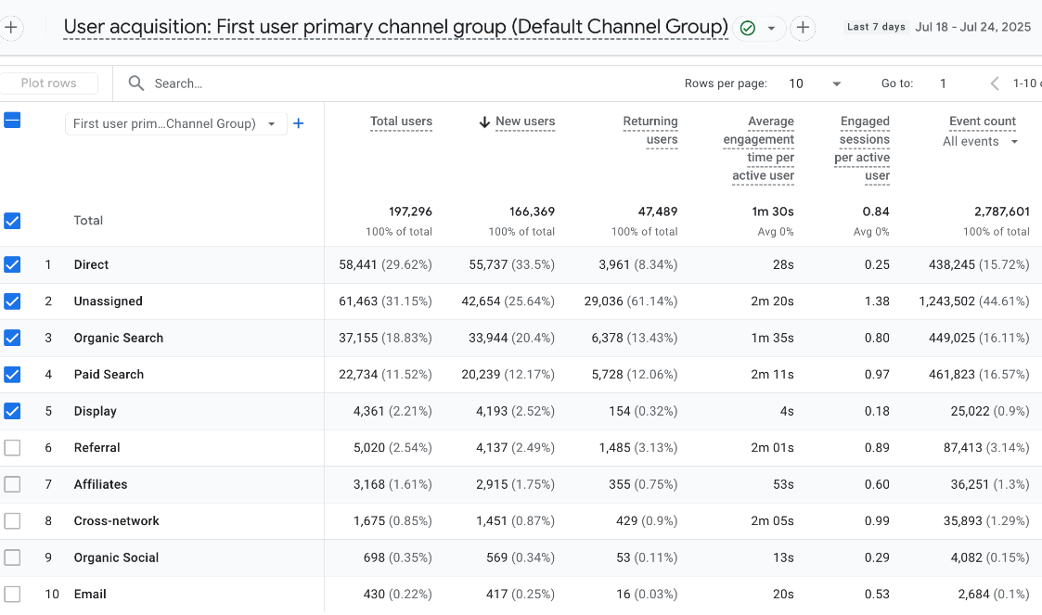

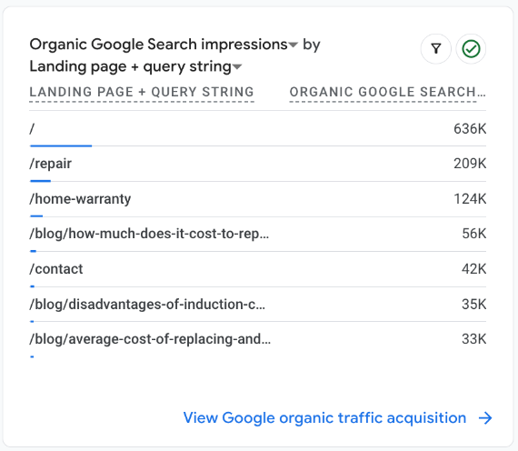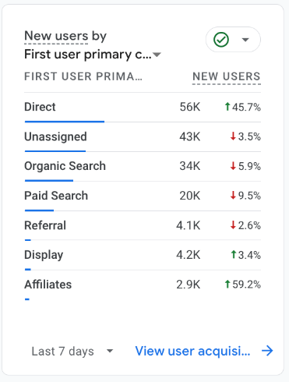

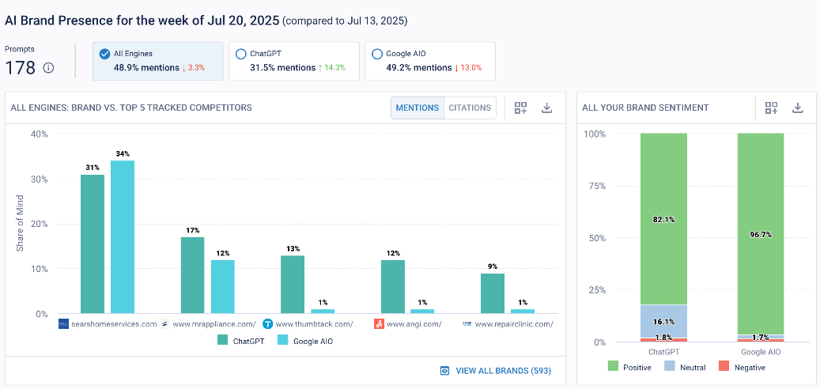

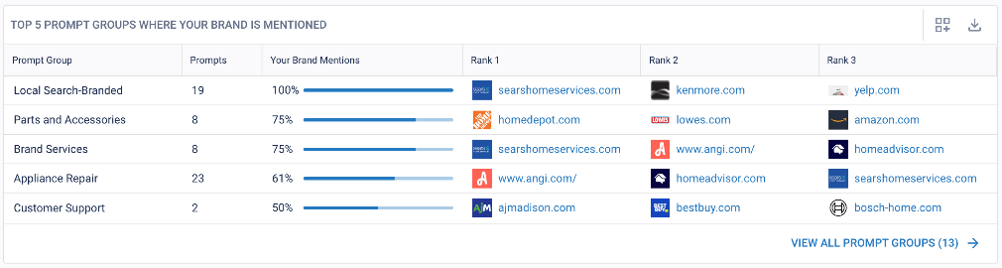

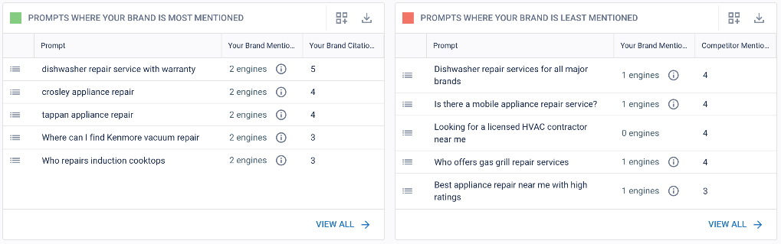

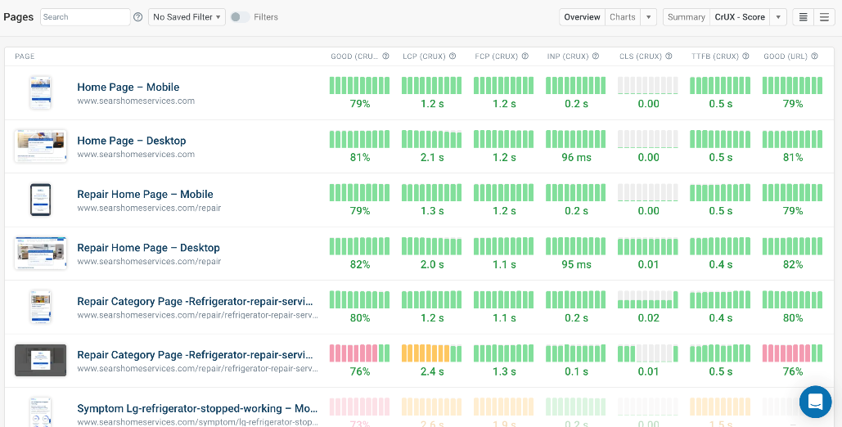

What We Accomplished This Week

* **Blocked Suspicious Email Activity**: Implemented controls to prevent suspicious email addresses from creating service orders. This mitigates inflated order and cancellation metrics caused by likely test or fraudulent activity. Users are prompted to enter a valid email address to be able to proceed with booking
* **New Brands Added**: Integrated **Beko** and **Thor** into the service brand list, enhancing support for a broader range of products.
* **Secured ODP Rollout (Pilot Phase)**: Launched a **secured version of the Order Details Page (ODP)** during off-hours for internal testing. This introduces PII protection via a verification layer. The team plans to evaluate user experience impacts next week from data collected while it was out live.

In Progress

* **Suspicious Order Patterns**:
  + Approximately **5,500 suspicious orders** identified over the last three months, largely tied to fake or throwaway email IDs. These entries are artificially inflating both order creation and cancellation rates on [shs.com](http://shs.com/). Root cause analysis is in progress to identify sources and determine if automation or internal misuse by someone is contributing.
* **Technical Debt Remediation**:
  + Updating several **third-party packages** used across the codebase to ensure compatibility, performance, and security.
* **SEO Enhancements**:
  + Improving the **page structure of location-specific pages** to strengthen search engine visibility and ranking.
* **Accessibility Compliance**:
  + Actively addressing **WCAG (Web Content Accessibility Guidelines)** issues to improve the site's usability for all users.
* **WhatsApp Integration & Experimentation**:
  + Continued testing of the **WhatsApp agent for appointment scheduling**.
  + Parallel expansion of this functionality to the **Maintain offering**.
  + Exploring solutions to resolve **source channel attribution issues.**
* **D2C Recall Development**:
  + Active development has begun even as **SOM** is still in progress.
  + Both **frontend and backend components** are being developed cncurrently to accelerate rollout.